King’s College London graduate teachers speak out
Times Higher Education, May 14, 2015

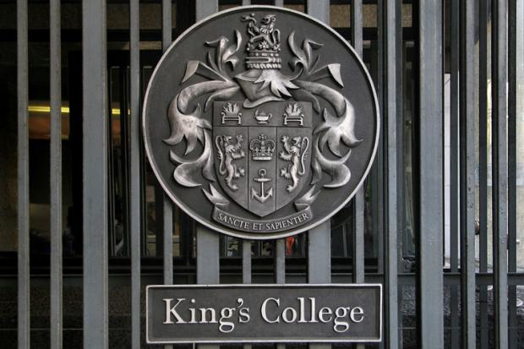
More than 95 per cent of graduate teaching assistants at a London university say they work longer than their contracted hours, a survey has found.
About 56 per cent of those surveyed at King’s College London said that this affects the quality of teaching, marking, feedback or learning they provide for students.
One GTA said that they could not provide the standards students deserve unless they “consistently and persistently work extra hours for free” and another said that they are “treated like free labour”.
GTAs are generally PhD students employed by universities to teach undergraduate and postgraduate courses. Duties can include giving lectures, running seminars, marking assignments, demonstrating in laboratories and providing pastoral support.
GTAs at King’s are the latest in a line of junior academic staff from several universities to complain about their working conditions.
Last year fractional staff at Soas, University of London refused to mark assignments after a survey revealed that half of their work was unpaid.
Campaigns to improve GTA pay have taken place at the University of Leeds, the University of Warwick, Queen Mary University of London, London Metropolitan University and the University of Glasgow.
A group of GTAs at King’s came together to find out about the work that other GTAs at the institution do. The survey of about 200 PhD students finds that 61 per cent said they “very often” work more than their contracted hours. Almost 80 per cent said that they did unpaid work to complete tasks.
Overall two-thirds said that they felt they were unfairly or very unfairly paid overall, with almost 80 per cent singling out preparation as the most poorly paid task, followed by marking.
More than a third said that they worked 10 or more hours over their contract to mark student’s work. More than 51 per cent reported working 10 or more extra hours to prepare for classes and 27 per cent said that preparation took 30 hours or more above their contracted hours.
One GTA said: “My students cannot receive the standard of teaching or feedback that they expect or deserve, or that the university promises them, unless I consistently and persistently work extra hours for free.”
Another added: “GTAs are treated like free labour and are not respected.”
The survey also asked how supported GTAs at King’s felt when balancing their own research with teaching duties. About 30 per cent said that they felt unsupported or very unsupported and more than half did not know who to discuss pay and working conditions with.
More than 20 per cent of respondents said they felt unvalued or very unvalued by their departments.
The group told Times Higher Education that they are now waiting for a response from management.

