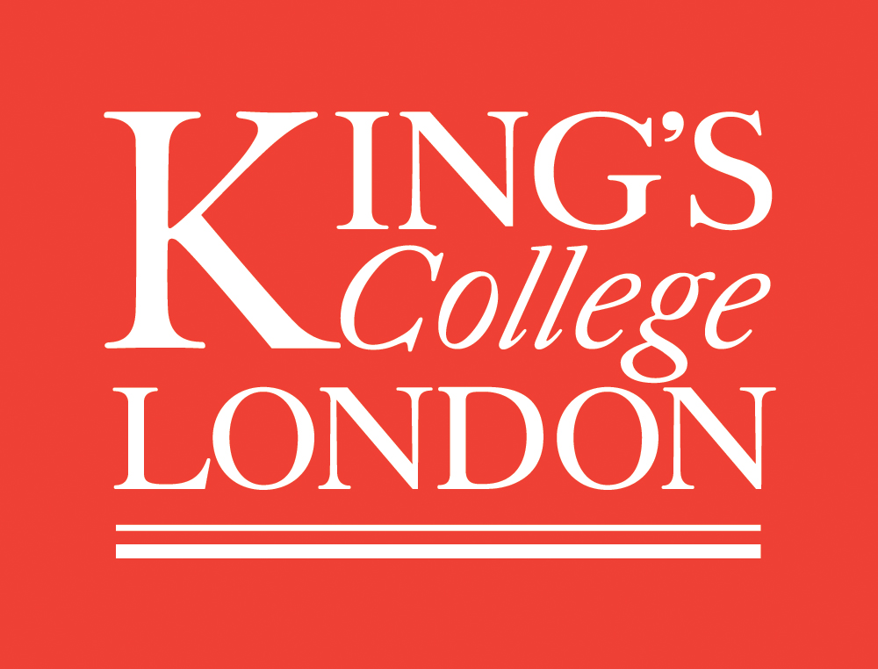
International Law Association
British Branch Spring Conference 2014
Foundations and Futures of International Law

23-24 May 2014, The Dickson Poon School of Law, King’s College London

FRIDAY 23 MAY 2014

09.30-10.00 Registration (Entrance Hall)

10.00-10.10 Welcome by Professor David Caron, Dean of The Dickson Poon School of Law, King’s College London (Safra)

10:10-11:00 Keynote Address by Professor James Crawford, University of Cambridge, ‘The identification and development of customary international law’ (Safra)

11.00-11.15 Coffee Break

11.15-12.45 FIRST Parallel Panel SESSION

Panel I: The Relationship between National, Regional and International Legal Orders (K2.31)

Chair: Lord Judge (Dickson Poon Distinguished Visitor, King’s College London)

- Dr Elena Katselli (Newcastle University), ‘Fragmentation, Political Realism and the European Court of Human Rights’
- Dr Gregory Messenger (University of Oxford), ‘Globalized Legal Process and the Development of International Law: Insights from the WTO’
- Dr Aoife O’Donoghue (Durham University), ‘Community, Constituency and the Future of Global Governance’
- Professor Chiara Giorgetti (University of Richmond), ‘Horizontal and Vertical Relationships of International Courts and Tribunals’

Panel II: The History and Future of Regulating the Oceans (Safra)

Chair: Professor David Caron (King’s College London)

- Dr Henry Jones (Durham University), ‘Lines in the Ocean and Citizens of the Sea – A Salt Water History of International Law’
- Professor Steven Haines (University of Greenwich), ‘The End of the Grotian Era?: The Nature of Ocean Governance in the 21st Century’
- Patrick Wall (Australian Attorney-General’s Department), ‘“See You in Court”: When do States Submit their Disputes to International Adjudication?’

Panel III: On Sovereignty (K3.11)

Chair: Professor John Tasioulas (University College London)

- Scott Sheeran (University of Essex),‘Reconceptualising the Foundations and Interpretation of International Law: Understanding State Sovereignty and Human Dignity’
- Dr Margot Salomon (London School of Economics), ‘The Turn to Cosmopolitanism in International Human Rights Law’
- Professor Thomas Pogge (Yale University), ‘Global Justice and International Law’
- Professor Eyal Benvenisti (Tel Aviv University), ‘Sovereigns as Trustees of Humanity’

12.45-14.00 Lunch

14.00-15.00 Presentation and Comment (Safra)

Chair: (Herbert Smith Freehills) TBC
- Professor Paul B. Stephan (University of Virginia), ‘Restating the Foreign Relations Law of the United States: The State of Play for the Fourth Restatement’
- Commentator: Chanaka Wickremasinghe (FCO)

15.00-16.30 SECOND Parallel Panel SESSION

Panel I: The Trafficking, Movement and Protection of Human Beings (K2.31)

Chair: Professor Satvinder Juss (King’s College London)

- Lorna McGregor (University of Essex), ‘The Renaissance of Due Diligence: An Effective Principle to Prevent and Protect against Trafficking in Human Beings?’
- Dr Anicée Van Engeland (School of Oriental and African Studies, University of London), ‘An Argument in Favour of Transnational Refugee Law: An Analysis of the Case of Afghan Refugees’
- Benjamin Thomas Greer (Office of the Attorney General, California Department of Justice), ‘California’s Anti-Trafficking Supply Chain Transparency Act: What It Is and How It Works’

Panel II: Technological Futures and Law of Armed Conflict (Safra)

Chair: Andrew Dodsworth (Ministry of Defense)

- Dr Marco Roscini (University of Westminster), ‘How to Apply the Principle of Proportionality to Cyber Targeting’
- Dr Agnieszka Jachec-Neale (British Institute of International and Comparative Law), ‘Data as Military Objective – Is the Emerging Debate Purely Academic?’
- Dr Jack McDonald (King’s College London), ‘Autonomous Weapons, Autonomous Agents and State Obligations Under the Laws of Armed Conflict’
- Professor Thomas Rid (King’s College London), ‘The Challenge of Automation’

16.30-16.45 Coffee break

16.45-18.15 THIRD Parallel Panel SESSION

Panel I: Human Rights in a Digital World (Safra)

Chair: Dr Philippa Webb (King’s College London)

- Lanah Kammourieh (Université Panthéon-Assas, Paris II), ‘Hacked Open: Spying in the Digital Age and the Need for an International Privacy Paradigm’
- Dr Russell Buchan (University of Sheffield), ‘Cyber Espionage and International Law’
- Dr Sejal Parmar (Central European University), ‘Freedom of Expression and Mass Surveillance’
- Jemima Stratford QC (Brick Court Chambers), ‘Is RIPA Fit for Purpose?’

Panel II: Jurisdictional Challenges and Accountability in a Transnational Context (K2.31)

Chair: Jeremy Carver CBE (President, International Law Association British Branch)

- Ursula Tracy Doyle (Northern Kentucky University), ‘Killing Them with Kindness: Why US Courts Should Solicit Input from the Most Interested Country before Denying Jurisdiction over Corporate Human Rights Abuse Cases on the Basis of International Comity’
- Merryl Lawry-White (International Court of Justice), ‘The Bright and Shifting Future of Reparation under International Law’
- Dr Jiewuh Song (Goethe University), ‘Sovereignty, Enforcement and International Law’
- Dr Yaël Ronen (Sha'arei Mishpat Academic Center), ‘Your Business is My Business: Corporations as Guardians of International Law’

Panel III: The Future of Old Schools (K3.11)

Chair: Dr Thomas Schultz (King’s College London)

- Professor John Linarelli (Swansea University), ‘Enlightenment International Law’
- Teerawat Wongkaew (Graduate Institute of International and Development Studies), ‘Buddhist Conception of International Law: The Path towards “Enlightment”’
- Professor Yuliya Guseva (Rutgers School of Law, Newark), ‘KGB’s Legacy: Transplanting Efficient Financial Infrastructure without Efficiency’

18.15-19.00 Drinks Reception, King’s College London

19.30-22.30 Conference Dinner, Inner Temple

After Dinner Speech by Professor Philip Allott (University of Cambridge), ‘The Idealist’s Dilemma’

SATURDAY 24 MAY 2014

9:00-9:30: International Law Association British Branch Council Meeting (open to Council members) (River Room) and Annual General Meeting (open to ILA British Branch members) (Safra)

9.30-11:00: FOURTH Parallel Panel SESSION:

Panel I: The Outer Limits of Environmental Protection under International Law (K2.31)

Chair: Professor Alan Boyle (University of Edinburgh)

- Dr Emanuela Orlando (University of Sussex), ‘International Law, The EU Legal Order and the Quest for Appropriate Responses to Environmental Harm: Towards Mutual Supportiveness?’
- Jessica Duggan-Larkin (University College London), ‘The UN Charter and Climate Change: Can the Obligations of States under Articles 55(c) and 56 Support Effective Global Responses?’
- Dr Nengye Liu (University of Dundee), ‘International Law for the Protection of Marine Biodiversity in the Changing Arctic: Challenges and Prospects from an EU Perspective’

Panel II: Avoiding and Regulating Armed Conflict (K3.11)

Chair: Professor James Gow (King's College London)

- Sean Aughey (11 KBW Chambers), ‘Foundations and Futures of IHL and HRL: A View from the Bar’
- Professor Jeffrey Davis (University of Maryland, Baltimore), ‘Uncloaking Secrecy in International Security Operations – International Law in Domestic Courts in Terrorism Cases’
- Dr Aurel Sari (University of Exeter), ‘Human Rights on the Battlefield: Terminate with Extreme Prejudice?’
- Danny Auron (Adjunct Professor, Fordham University), ‘Relevance of Derecognition to Middle East since 2011’

Panel III: The Sources of International Law Revisited (Safra)

Chair: Sir Frank Berman KCMG QC (Essex Court Chambers and University of Oxford)

- Dr Danae Azaria (University College London), ‘The International Law Commission as an Interpreter’
- Dr Eirik Bjorge (University of Oxford), ‘Splitting the Difference: The Vienna Rules and Treaty Interpretation by the French and the UK Courts’
- Professor Başak Çali and Professor Elizabeth Ann Griffin (Jindal Global University), ‘Revisiting the Customary International Law of Human Rights: The Role of the United Nations Human Rights Charter-Based Machinery in the Formation and Maintenance of the Customary International Law of Human Rights'
- Dr Panos Merkouris (University of Groningen), ‘Interpretation of Customary International Law: A Case of Interpretative “blind spot”?’

11.00-11.15 Coffee break

11.15-13.00 FIFTH Parallel Panel SESSION

Panel I: Law of Armed Conflict: Emerging Challenges (K3.11)

Chair: Professor Guglielmo Verdirame (King’s College London)

- Professor Diane Marie Amann (University of Georgia), ‘Protection of Persons in Militias in Time of Civil War’
- Robert McLaughlin (Australian National University), ‘Customary International Law on Maritime Insurgencies as a Guide to Filling a Gap in the Modern Law of Armed Conflict’
- Dr Dug Cubie (University College Cork), ‘The Wilful Denial of Humanitarian Assistance: Conceptualising the Protection of Persons in Humanitarian Crises’
- Dr Jadranka Petrovic (Monash University), ‘Regulation of International Arms Trade: The Arms Trade Treaty and Its Capacity to Halt the Illicit Trade in Arms’

Panel II: Contemporary boundary delimitation issues and island sovereignty questions (Safra)

Chair: Richard Schofield (King's College London)

- Timothy Lindsay (Dechert), 'Drawing Lines: How do International Tribunals Assess Competing Evidence?'
- Charles Claypoole (Latham & Watkins), 'The Interplay between Legal and Technical Factors in the Delimitation of the EEZ and the Continental Shelf: Some Observations in Light of Recent Jurisprudence'
- Ioannis Konstantinidis (Volterra Fietta), 'Delimitation of maritime boundaries up to and beyond 200 nautical miles off Latin America: A few thoughts in light of recent ICJ jurisprudence'
- Richard Schofield (King's College London), 'States Behaving Badly (in Island Sovereignty Disputes)? Reflections on British Colonial Practice'

Panel III: The Protection of Foreign Investment (K2.31)

Chair: Giorgio Mandelli, Volterra Fietta

- Erman Ozgur (University of Dundee), ‘Institutional Fundamentals of International Investment Law: Political Constraints on Investment Treaty Arbitration’
- Mona Pinchis (King’s College London), ‘The Ancestry of “Equitable Treatment” in Trade: Lessons from the League of Nations during the Inter-War Period’
- Rumiana Yotova (University of Cambridge), ‘Transnational Public Policy: Promoting the Rule of Law in Foreign Direct Investment?’
- Dr Martins Paparinskis (University College London), ‘Investment Protection Law – Analogies and Foundations of International Law’

13.00-13.30 Closing Plenary (Safra)

