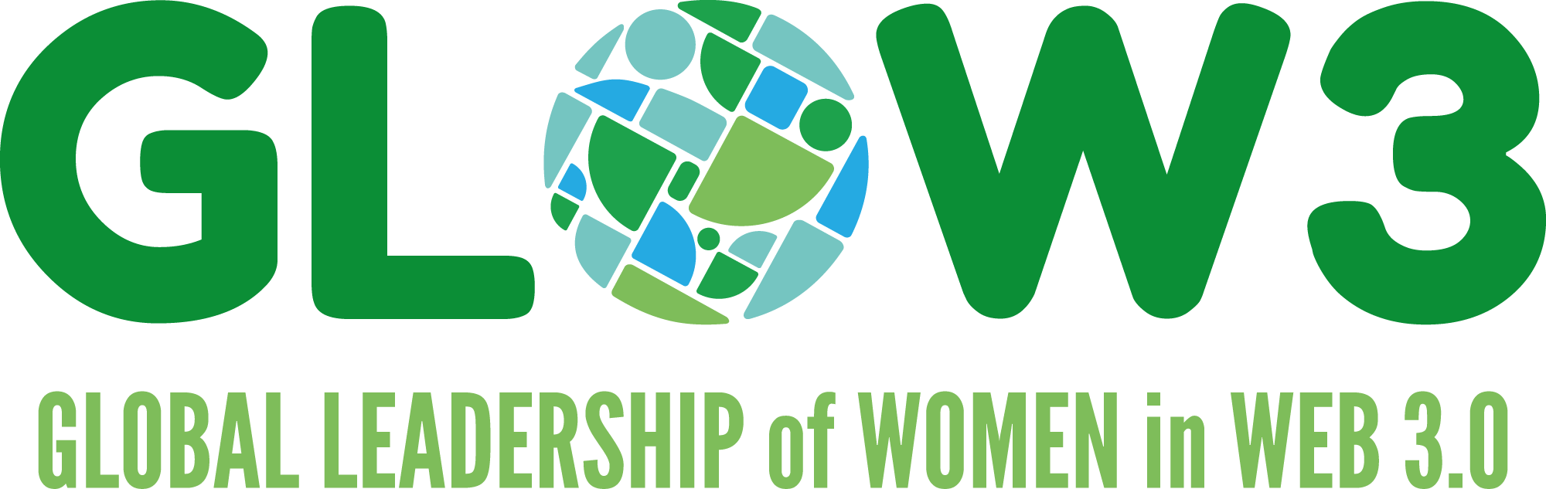

Artist Programme: Application Form

- Name

Legal name for contract purposes:

Preferred name:

Artist/avatar name:

Pronouns:

- Nationality & Country of Residence

Nationality:

Country of Residence:

- Contact Details

Email address:

Mobile phone number:

Postal address:

- Workshop participation is a requirement of this programme. Please confirm that, if selected, you would be able to attend the workshops as listed in the call-out documentation (*timings TBC depending on time zones of participants). Please specify whether you would plan to attend in person or online.
*delete as appropriate
- 11 + 12 September 2023 (10am-5pm) [London] [in-person only]
- 17 + 18 October 2023 (10am-5pm) [Virtual & Immersive Production Studio, Nottingham] [in-person only]
- 15 November 2023 [London/Online]*
- 6 December 2023 [London/Online]*
- 17 January 2024 [London/Online]*

- Title of artwork:
- Format of artwork [please list all technologies used to make the work and the technologies that would be required to exhibit the work]:
- Logline (i.e. one or two sentences to convey the essence of the work):
- Long description (max. 200 words):

- Please describe how your proposed artwork connects to the GLoW3 project aims themes and questions, or how you might wish to explore your own theme or question that builds from these (max. 150 words)
- Please describe how audiences will access and engage with the artwork [in both physical and digital space]. Please also include detail of how your artwork might respond to the site of the exhibition [this can be internally: Bush House or externally: Strand/Aldwych pedestrianised area]: (max. 200 words)
- In addition to your own resources, what other resources would you require to produce the project (equipment, software, room space, technical assistance)?
- What additional skills would you need to develop in order to produce the project?
- Please share any links to your previous work:
- Budget: Please provide an outline and timeframe of how you will use the £5000 budget (travel, subsistence, hotel costs.)
- We are committed to ensuring that successful applicants can access all aspects of the programme. Please let us know if you have any access requirements or support needs and please feel free to contact us to discuss.
Please append a 2-page CV to this application form and submit as an attachment, with the email subject line “GLOW3 ARTIST PROGRAMME APPLICATION” to: ahpostaward@kcl.ac.uk
before the deadline - 12 June 2023 [9:00 BST – 10:00 UTC]

