**Strand Campus Bicycle Facilities**

Facilities for over 150 bicycles have been built within a dedicated area at the Strand campus; the facilities are located within a secure area known locally as the “Old Playground”

The new facilities include secure card access in and out for KCL Staff and Students, fixed Sheffield type bicycle racks and shelters with new CCTV monitoring. Brand new shower facilities are provided in K-1.35.

These areas will open on Monday 5th December and the Quad bicycle racks will be decommissioned on this date.

**Access**

Access for the Bicycle parking area will be given to KCL bicycle users on request. Please complete the bicycle registration form and take to the Strand Security Control Room located to the right of the vehicle entrance and up the stairs, to have your KCL ID card activated for access.

The bicycle parking facilities are located within the Old Playground located at the top of Strand Lane, accessible from Temple Place, just off the Embankment. There is also pedestrian access via Surrey Steps.

Weekend access to the campus is only available via Strand Security and therefore weekend bicycle parking will be available from the Strand Vehicle/Quad entrance only. Please see attached map.

**Bicycle Storage**

The College makes every effort to ensure the safety of user’s bicycles however the College takes no responsibility or liability for the loss or damage of user’s bicycles or equipment. Bicycles are stored at owner’s risk.

Bicycles:

* May only be stored in designated bicycle storage areas.
* Shall not be left so as to obstruct any emergency or fire exits to any building or Impede pedestrian traffic, this includes ramps, railings or entrances designated for disabled access.
* Are not to be taken into any campus building without the expressed, written permission of the Campus Operations Manager.
* Any bicycle stored in an area not designated for cycle storage may be removed, and will be stored in a secure location. The College is not responsible for reimbursing the cost of any locking device removed, or damage caused to the bicycle in order to remove said bicycle.
* Owners of bicycles that have been removed must prove ownership in order to have the bicycle in question returned to them:
  + A sales receipt for the bicycle
* A detailed description of the bicycle
* The location the bicycle was last locked
* A key that operates the lock that was used to originally secure the bicycle

**Abandoned Bicycles**

Bicycles that have been abandoned can take up valuable cycle parking space and cause a nuisance or obstruction to pedestrians and other bicycle users.

Any bicycle that appears to be abandoned will have a notice attached to the bicycle warning the owner that they must contact Security to claim the bicycle or move it, or it may be removed by the College. The owner will be given 7 days to do this.  Once a bicycle has been removed it will stored in a secure location for a period of 21 days before being disposed of or donated to charity.

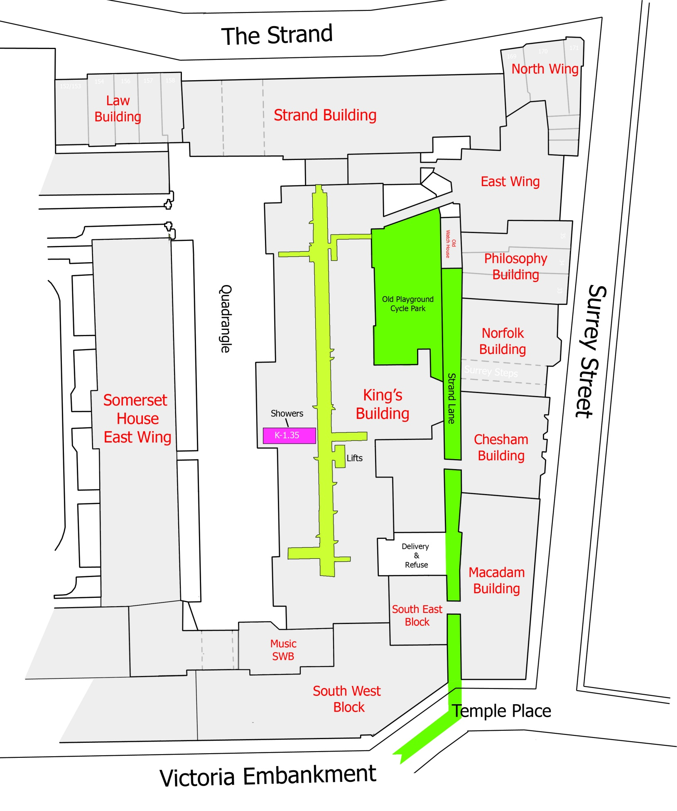

**Cycle Security**

**How to lock your bike…**

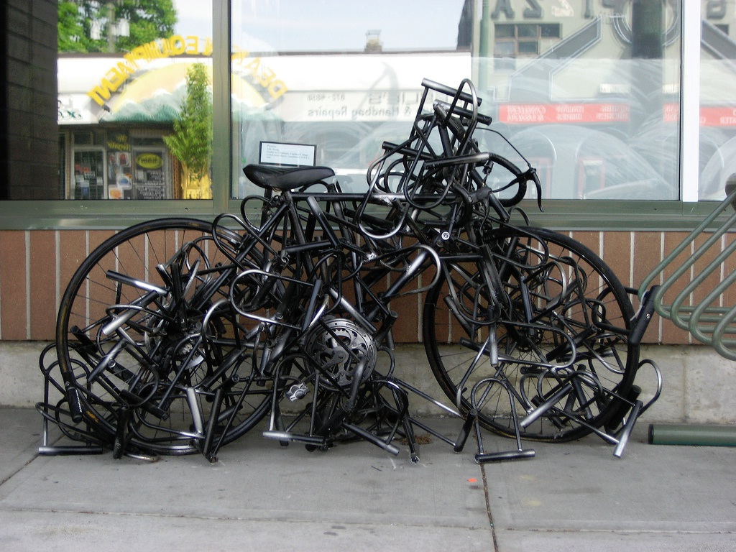

1. Ideally, use TWO secure-rated locks for maximum security

2. Lock both wheels and the frame (or wheel and frame with one lock)

3. Always lock the frame to a solid object such as a bike stand

4. Two types of lock (chain/cable and D-lock) are harder to break

5. Remove all your bike accessories every time you leave it unattended

**Types of bike lock and other locking mechanisms**

**How much to spend**

It’s generally advised to spend at least 10% of the value of your bike on a lock, and, if you can, to use two different types of lock to deter thieves.

Locks are generally sold with two keys; always keep your spare key in a safe place in case your key is lost or stolen, and keep a note of your key number (this should be on the key itself or come with the lock when you buy it) so you can replace it if all else fails.

Some lock manufacturers offer warranties to replace the lock if your cycle is stolen while locked with their lock. You may have to register and/or pay for the service.

**D-locks**

These are rigid steel locks in a D or U shape, generally very heavy and tough-looking.

When you lock up, try to fit the stand, the rim of one of the wheels and the frame in the D.

By securing your wheel as well you’ll not only make it harder for thieves to take, but there’ll also be less space in the D which will prevent thieves from inserting bars or jacks into the space to lever the lock open.

It’s best to angle the lock so that the opening is facing down. This prevents thieves from pouring in substances such as glue to prevent the owner from being able to retrieve the bike, giving them the chance to force the lock open later.

**Cable locks**

Cable locks are more flexible so can be used in situations where a D lock might not fit, but thinner, cheaper versions are very easily cut through. However, thicker cable locks can be very secure.

Thinner cables are useful in combination with other locks to secure parts like wheels or your saddle so that you don’t need to remove them every time you leave your bike.

**Chains and padlocks**

These can be very heavy and impractical to cart around, but they are tough and a good-quality hardened heavy-duty chain combined with a couple of very good hardened padlocks may be the strongest option available.

**Extension cables**

D locks and cable locks often only allow you to lock the frame and one wheel of your bike, so you may decide to buy two D locks to secure both wheels, or to buy a cable lock to secure the second wheel.

Alternatively, you could combine your D lock with an ‘extension’ cable – a flexible cable with open loop ends which you can loop through the wheel you haven’t locked and secure to the D lock before you lock it.

**Solid secure ratings**

There is a three tier security grading system developed by Sold Secure (a non-profit making company which assesses security products) which is used by many insurance companies.

At the highest level are the Gold rated locking devices. These give you maximum security and may even grant you a reduction in insurance premiums, depending on your insurance provider and the type of lock; but they may be too bulky or expensive for the average user.

The Silver and Bronze levels may be lighter and cheaper but still offer defence against the opportunist thief.

**Lock maintenance**

Always take good care of your lock and key – treatment such as leaving your lock outdoors for prolonged periods can take its toll and if your lock brakes, you may find it very difficult to rescue your bike.

A drop of oil in the lock mechanism every couple of months, especially in winter, is a very sensible move.

**Locking skewers or wheel nuts**

If you have quick release mechanisms on your bike, it can be very easy for thieves to steal your saddle and wheels. You may wish to replace the quick release mechanisms with ordinary bolts or nuts which fit a spanner or allen key; or you can buy special locking nuts which can only be undone with a specially designed version of an allen key which is sold with the bolt.

Information provided by London Cycling Campaign <http://lcc.org.uk/articles/types-of-lock>