Molecular Modelling Virtual Chemistry Resource

PyMol Experiment Worksheet

Do you want to know what it is like to have a career in chemistry? Want to know the different careers a chemistry degree could lead you to? Do you want to engage in chemistry outside of school?

Our #outtheboxthinking resources are aimed to help you do just that, developed by Dr Grace Walden in collaboration with Dr Helen Coulshed. With these resources we aim to:

* Inspire the next generation of chemists
* Encourage widespread participation and engagement with chemistry
* Link chemistry curriculum to research happening here at King’s
* Raise awareness of the interdisciplinary nature of modern chemistry
* Help you understand the wide range of careers available to chemistry graduates

We strive to ensure the collaborative nature of chemistry is inbuilt in our undergraduate courses. We help those who choose to study with us learn how to become part of a multidisciplinary team with a vast array of transferable skills.

Our approach means our students go into a diverse range of careers after graduation. These include roles in chemistry, education, fashion, finance, retail, and more.

Several graduates have become CEO’s of their own ‘start-ups’ Over forty percent of our graduates go onto further education, such as undertaking a PhD, or to teach chemistry to the next generation of scientists.

Fill out our resource questionnaires

For our project to be a success we need to see if our resources have helped to change your attitudes towards chemistry. Help us collect this data by filling out a questionnaire before and after you complete this resource.

Pre: <https://kings.onlinesurveys.ac.uk/pre_resource_questionnaire_outtheboxthinking>

Post: <https://kings.onlinesurveys.ac.uk/post-questionnaire-for-outtheboxthinking-resources>

Share your experience with us on social media @kclchemoutreach

Send us photos, comments, or thoughts to either our twitter or Instagram accounts using the hashtag #outtheboxthinking. We also encourage you to make a poster of your data and email it to us. We hope you enjoy this resource as much as we have enjoyed creating it.

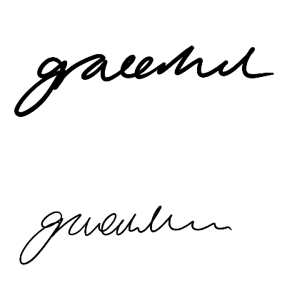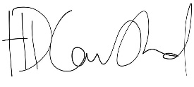

**Dr Grace Walden**

#Outtheboxthinking Project Co-Ordinator

**Dr Helen Coulshed**

Lecturer in Chemical Education



Before you start

* Complete our pre experiment questionnaire <https://kings.onlinesurveys.ac.uk/pre_resource_questionnaire_outtheboxthinking>
* Read the background theory/watch our background theory video on our outreach page <https://www.kcl.ac.uk/chemistry/outreach>
* Download PyMol using this link <https://pymol.org/edu/?q=educational/>
* Fill out the information about yourself and follow any further instructions given

If you are unsure of anything to enter in the fields, you can use the information supplied here.

If you do not have a telephone number, you can mark this as “N/A”. Your institution can either be “Kings College London” or your school. Select “Other” as your degree. Subject matter is “Chemistry”. The advisor name can be “Kings College London”. Your anticipated year award will be “Unknown”.

Learning outcomes

You will examine four small molecule drug candidates and their interactions with a target protein. You will understand that changes in chemical structure can have a large effect on its properties and the drug’s ability to interact with its target.

**After completing our experiment, you should be able to:**

* Understand bonding that allows binding of drug molecules to protein receptors
* Understand the importance of testing a library of derivatives of a compound of interest (drug molecule)
* Understand the importance of computational chemistry and its application in treating diseases
* Select an appropriate drug molecule candidate and defend your decision

**Transferable skills you will practice during this session:**

* Critical thinking
* Decision making
* Independent learning
* Interdisciplinary working
* IT skills
* Time management

Work your way through the worksheet below

Throughout the worksheet are sections where you can enter text to answer questions. You will need to click or tap to enter your answer. These sections look like this. Click or tap here to enter your answer.

There are also drop-down menu options where you need to click or tap the box, select the arrow on the right-hand side and choose and option. These sections look like this. Choose an item.

Get used to the controls in PyMol

These controls work either with a mouse or with laptop buttons. You will need these throughout the worksheet.

|  |  |
| --- | --- |
| Zoom in | Hold down the right mouse button and drag the mouse up. |
| Zoom out | Hold down the right mouse button and drag the mouse down. |
| Rotate molecule | Hold down the left mouse button and drag mouse left, right, up and down. |
| Move the molecule | Hold down the mouse wheel and drag the mouse left, right, up and down. |
| Reset the image | Click the left-hand button of the image |
| Remove the protein surface | Scroll down with the mouse wheel or track pad |

Background theory

All matter is composed of tiny particles called atoms which are described in the periodic table. Chemistry is the study of atoms and elements, and how these interact with each other. Small changes in the way elements are bonded together has a huge impact on the characteristics and properties of the resulting molecule. Chemists use this knowledge, and the understanding of elemental properties and reactivities, to produce new compounds every day.

Computational studies allow us to use the information we know about fundamental properties of molecules, atoms, and reaction kinetics to predict how interactions may occur between different molecules. The pharmaceutical industry is using artificial intelligence (AI) to collate the results of experiments completed by their chemists over the last few decades to identify new drug targets.

Computational chemists can investigate interactions between proteins and drug molecules and provide detailed data that is unavailable in conventional ‘wet lab’ experiments. Understanding drug interactions with proteins is particularly important as proteins are involved in nearly all biological reactions in the body, with malfunctions in these reactions often leading to disease. By understanding the interactions between proteins and chemicals in the body, scientists can design and synthesise specific molecules to target certain proteins to help treat disease. Specificity is essential to minimise unwanted side reactions in future patients.

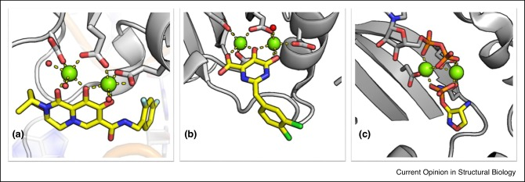PyMol is an open source software which can be used for the visualisation of molecules. Chemists use it to look at the interaction of drug molecules with proteins and produce clear images of these interactions. Ensuring clear understanding is an essential part of science communication, PyMol images are often included in scientific journals. Below are images from Dr Edina Rosta’s research group (**Figure 1**). Edina runs the largest computational chemistry group in the department of Chemistry at King’s.

Figure 1: Small drug molecules (yellow) interacting with magnesium ions (green) present inside an enzyme (grey). Published by chemistry researchers here at King’s.1

The experiment

In this activity, imagine you are a **computational chemist** that has been approached by **a drug development chemist** who wants to assess a new drug molecule to target to a protein implicated in a major disease. You have been given four drug candidates and need to decide which one(s) you think will have the best interaction with the protein (**Figure 2**). You will have to explain your reasoning to the **synthetic chemists** who will make the drugs and the **biochemists** who will test the drugs in cells.

4 Drug molecules based on the naturally occurring ligand Adenosine.Adenosine is an endogenous ligand (natural drug) that the drug development chemist has based their drug designs on. Adenosine functions as a neurotransmitter by binding to proteins called A2A receptor. These adenosine receptors are modulators of neurotransmitters and play a role in many neurological diseases such as Parkinson’s, Alzheimer’s, Huntington’s, and multiple sclerosis (MS). Therefore, it is a priority to the pharmaceutical industry that chemists synthesise drug molecules with strong interactions with these receptors, as they will have a wide range of potential therapeutic applications.

Figure 2: Drug molecule candidates based on adenosine given to you for analysis.

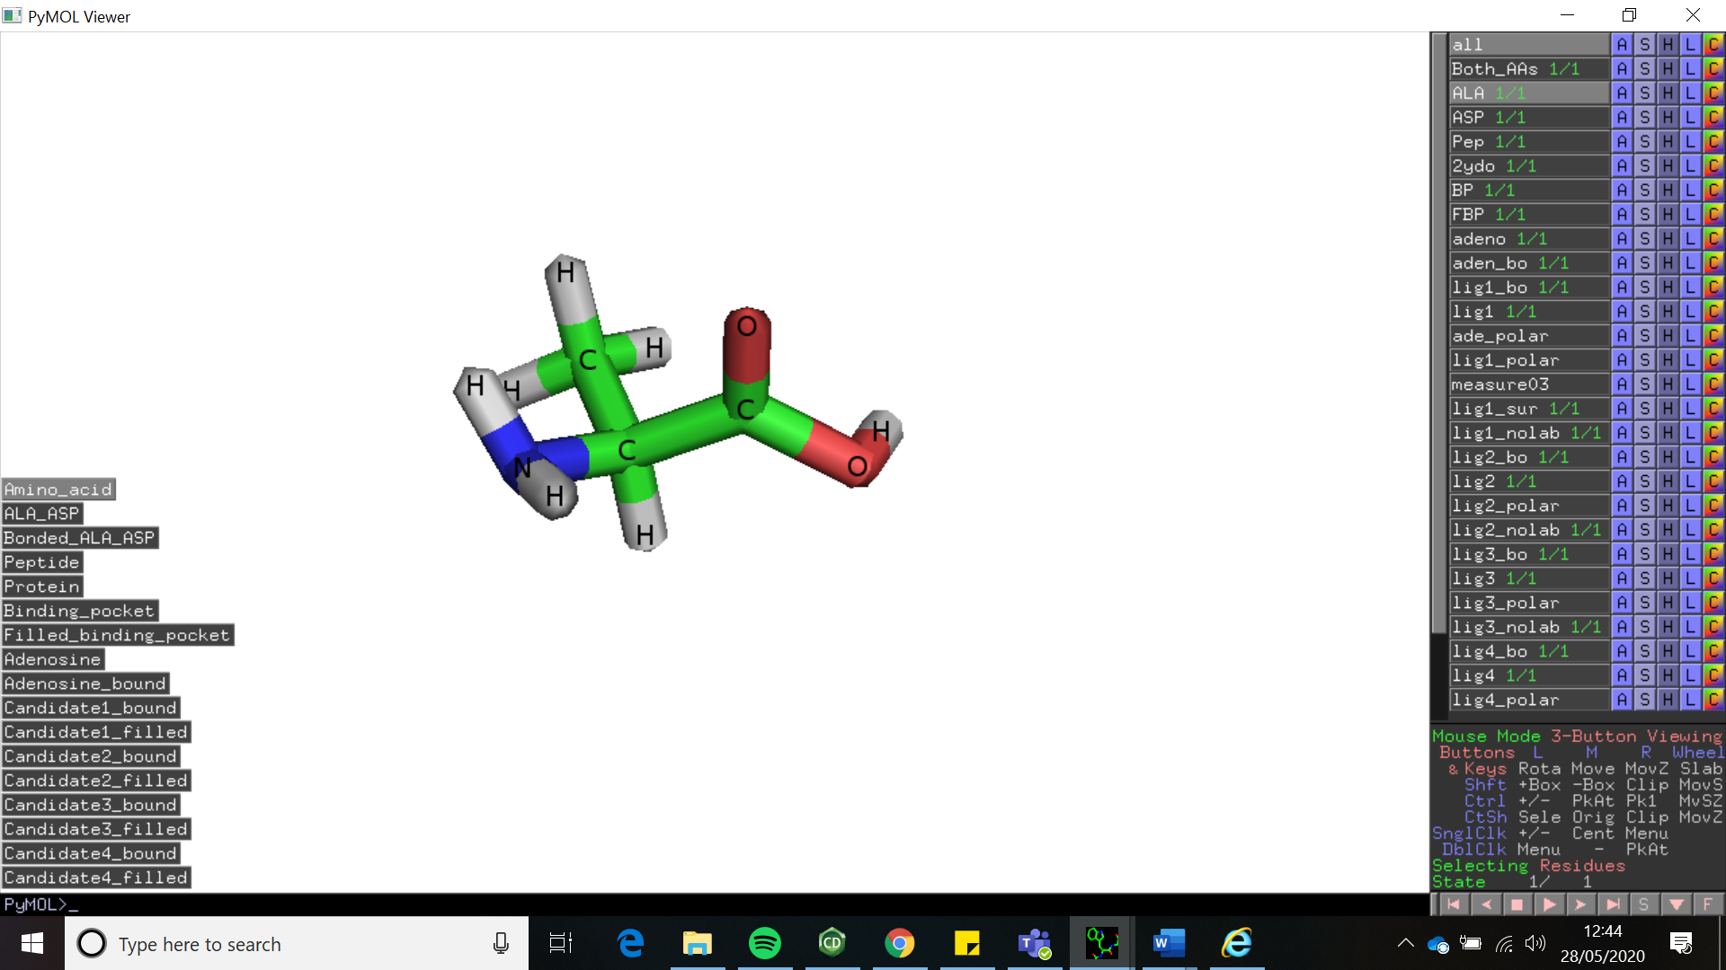Get Started

* **On the Left-hand side of your PyMol screen, you will see action buttons**

These allow you to visualise each molecule discussed. During this worksheet we will use different settings to explore the computational programme.

Exploring how proteins are formed

* **Press “Amino Acid”**

You are looking at an amino acid.

Amino acids are the building blocks of all proteins. All amino acids have the same basic structure. They consist of a central carbon connected to an amine, a carboxylic acid, and a side chain (often labelled 'R'). The side chain is unique to each amino acid and can be used to identify it. Look at the amino acid, identify the central carbon, carboxylic acid, and amine.

**Q. What is the R group in the side chain of this amino acid?**

Click or tap here to enter your answer.

**Q. Which amino acid is shown here?**

Click or tap here to enter your answer.

* **Press the button “ALA_ASP” and an additional amino acid will appear**

Here you can see two amino acids

**Q. What is the chemical formula of the side chain of the new amino acid**?

Click or tap here to enter your answer.

**Q. What is the name of the second, new amino acid?**

Click or tap here to enter your answer.

* **Press the button “Bonded_Ala_Asp”**

Here you can see two amino acids covalently bonded.

An important feature of amino acids is the presence of a carboxylic acid and an amine. These functional groups react together to form an amide bond.

**Q. What colour(s) is the amide bond connecting the two amino acids?** Include a screen shot in your answer.

Click or tap here to enter your answer.

**Q. Which elements have been lost from each amino acid following their bonding**?

You can go back to “ALA_ASP” to look at the unbonded structures to help if needed.

Amino acid 1:Click or tap here to enter your answer.

Amino acid 2: Click or tap here to enter your answer.

**Q. What molecule is lost as a side product of this reaction?**

Click or tap here to enter your answer.

**Q. What is the general name for this type of reaction?**

Click or tap here to enter text.

* **Click on the button “Peptide”**

You are now looking at a small peptide with multiple amino acids.

When multiple amino acids are reacted together this forms a peptide. Each amino acid within the peptide is labelled. Amino acids are typically given either a three-letter code or a one-letter code shorthand (e.g. GLY or G for glycine). Lists of the common amino acids and their three-letter and one-letter codes are readily available online.

**Q. Which 7 amino acids are present in this peptide**

Click or tap here to enter your answer.

* **Click on the button “Protein”.**

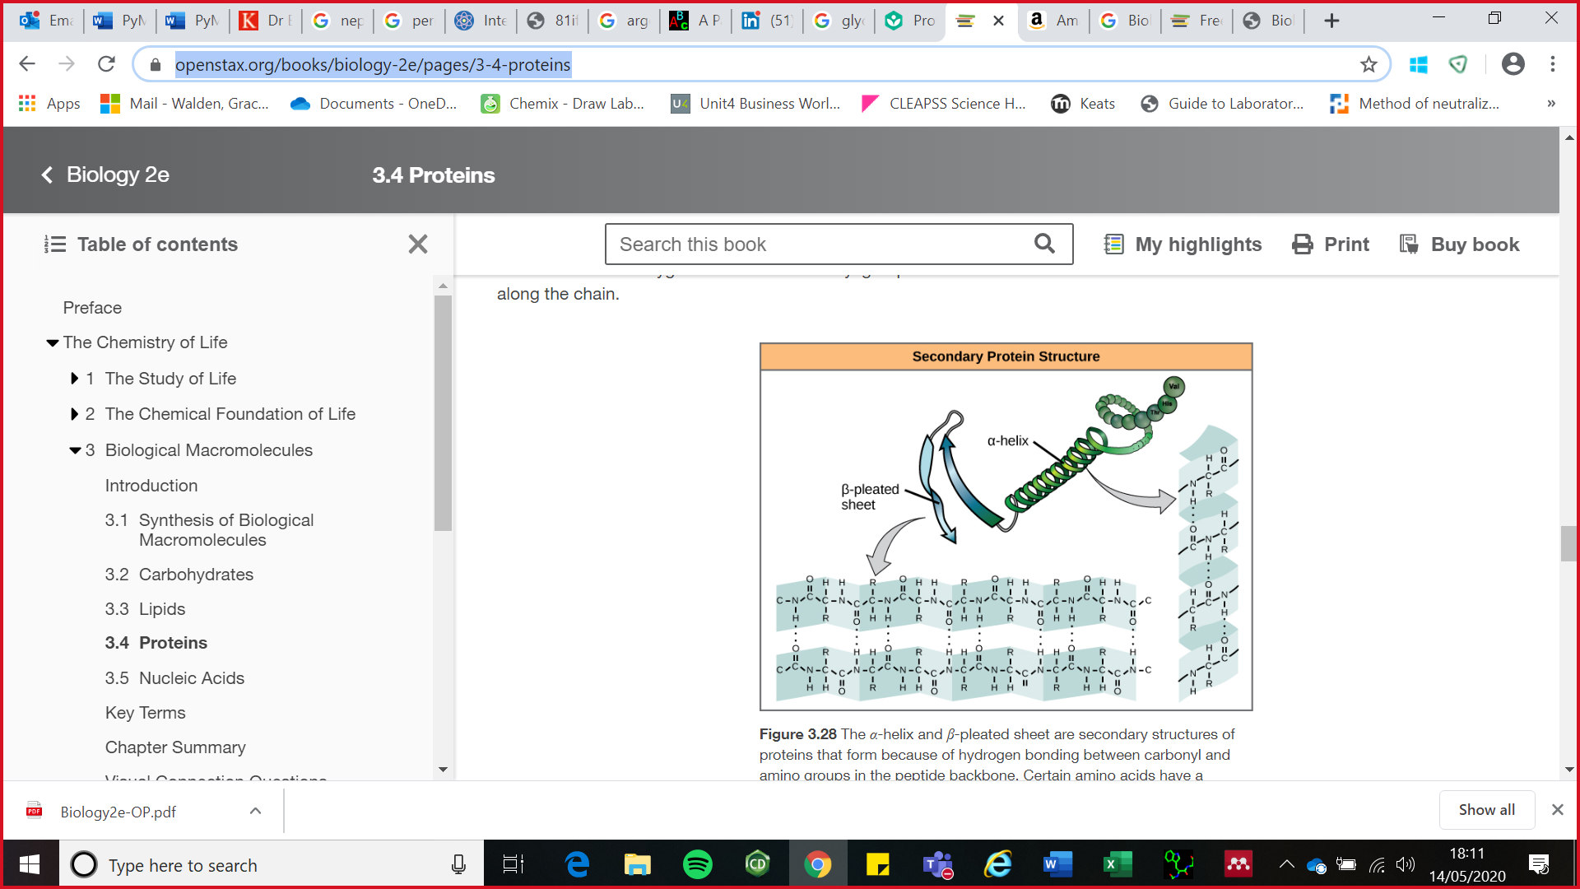You are now looking at the structure of a receptor protein.

A large linear peptide with over 15 amino acids is known as a “polypeptide”. Polypeptides are what all proteins consist of. The sequence of amino acids used to make the polypeptide, and therefore the resulting protein, determine the protein’s structure. Single changes in amino acids in the sequence can result in abnormal proteins being formed. Each amino acid in the sequence is numbered based on where it sits in the sequence and are known as “residues”. Large peptide chains fold into either alpha helices or beta pleated sheets depending on the interactions between the elements in the amino acid side chains. These secondary structures are formed by hydrogen bonding between the oxygen of the carbonyl of one amino acid and hydrogen of the amine (C=O---H-N) on another amino acid (**Figure 3**).

Figure 3: Example of alpha helices and beta pleated sheets, and the bonding that occurs in these structures shown as dashes between the hydrogens and oxygens.2



look at the protein structure.

The “coils” seen are alpha helices.   
Rotate the protein, the “flat triangles” are the beta pleated sheets. (There aren’t very many in this protein, so they are a little tricky to find).

**Q. Which protein do you think this structure might be? Hint – What protein is the drug trying to target**?

Click or tap here to enter your answer.

Exploring the protein’s binding pocket

* **Click on the button “Binding_Pocket”.**

In this structure you can see the drug molecule adenosine (pink/blue/red) bound at the adenosine binding pocket within the A2A receptor protein (green).

Proteins can contain a binding pocket where binding can occur with other molecules. In the A2A receptor there is a binding pocket in which adenosine can bind to elicit an effect.

* **Click the button “Filled_Binding_Pocket”**

You are now looking at the protein (grey) with adenosine (pink/blue) in the binding pocket.

The binding pocket has a specific molecular shape, so molecules which are too large or do not have the correct shape cannot bind. In this way molecule binding can be very specific to each protein.

**Rotate and zoom into the protein to see the drug molecule enveloped in the protein (grey). Scroll with your mouse wheel or track pad to look below the surface of the protein to visualise how the molecule fits in the pocket. (Look back at controls on page 2 if needed).**

Exploring how the drug molecule binds to the protein

* **Click on the button “Adenosine”**

You are now looking at the structure of adenosine.

Adenosine is the endogenous (naturally occurring in the body) drug molecule that binds to the A2A receptor protein.

**Q. Below is the skeletal structure of the chemical adenosine. Name all the functional groups highlighted**.

A: Click or tap here to enter your answer.

B: Click or tap here to enter your answer.

C: Click or tap here to enter your answer.

**Q. Which elements do you think are likely to be involved in the bonding of the adenosine molecule to the protein?**

Click or tap here to enter your answer.

* **Click the button “Adenosine_bound”**

You can see adenosine (pink/blue/red) bound in the binding pocket of the protein (green). The amino acids that are responsible for binding of the drug molecule are shown and labelled.

This protein has 433 amino acids in its sequence. Understanding how binding occurs at the binding pocket is important for chemists to be able to identify what is essential in a potential therapeutic target. Knowing the likely orientation of a molecule and which amino acids are involved in the binding of that molecule, creates a picture of which parts of the drug must be present for the effect to be seen.

Q. **Record which 4 amino acids are involved in the binding of adenosine to the protein, and where in the protein sequence these amino acids come**.

Click or tap here to enter your answer.

**Q. Which elements within adenosine are facilitating its binding to the protein?**

Click or tap here to enter your answer.

**Q. What type of bonding do you think is likely to be occurring between these elements?**

Click or tap here to enter your answer

Time to make your hypothesis



Look at the structure of adenosine compared to the drug molecule candidates below.

**Q. Think about all the information learnt so far about the binding of adenosine to the receptor protein. Looking at the structure of adenosine and which elements are important for binding, which drug candidate would you predict will have the best binding to the adenosine binding pocket of the protein and why**?



Click or tap here to enter your answer.

The experiment

* **Click through each of the candidate molecules one by one in the bound and the filled orientations. (eg. for candidate 1 look at “Candidate1_bound” and Candidate1_Filled”) Fill out the answers to the questions in the table below. When rating the binding remember that we want the drug candidate to bind to the adenosine binding pocket ideally with a higher affinity than adenosine. Remember to scroll your wheel downward to remove the surface of the protein to look at how well the molecule fits into the binding pocket when looking at the candidate filled.**

|  |  |  |  |  |
| --- | --- | --- | --- | --- |
|  | **1** | **2** | **3** | **4** |
| **How many amino acids are involved in the binding of this molecule to the protein?** | Click or tap here to enter text. | Click or tap here to enter text. | Click or tap here to enter text. | Click or tap here to enter text. |
| **Which amino acids are these, including their sequence number?** | Click or tap here to enter text. | Click or tap here to enter text. | Click or tap here to enter text. | Click or tap here to enter text. |
| **How many hydrogen donors/acceptors on the candidate molecule are facilitating binding to the protein?** | Click or tap here to enter text. | Click or tap here to enter text. | Click or tap here to enter text. | Click or tap here to enter text. |
| **Looking at the “candidate filled”. Does the molecule fit into the binding pocket?** | Choose an item. | Choose an item. | Choose an item. | Choose an item. |
| **Rate the binding of each molecule from 1-4. With 1 being best and 4 being worst.** | Choose an item. | Choose an item. | Choose an item. | Choose an item. |

Summarise your data

An important part of chemistry and science in general is being able to communicate your work in a way that anyone can understand. Imagine you are now explaining the results of your experiment to the **synthetic chemists** who will make the drugs and the **biochemists** who will test the drugs in cells.

**Q. Based on all the data you have gathered from your experiment in the table above, and everything else you have learnt throughout this worksheet, explain which candidate drug molecule you have chosen and why. You can use screen shots to help your audience understand your answer.**

Click or tap here to enter your answer.

What to do now you have finished

Now you have completed this workbook please save it using the following naming format putting in the correct information**.**

**“PyMol. Month_2020_School Name”**

Send it back to us at [chemistry-outreach@kcl.ac.uk](mailto:chemistry-outreach@kcl.ac.uk).

Read our answer sheet

Have a look through our answer sheet, which can be found on our outreach page: <https://www.kcl.ac.uk/chemistry/outreach>

Share your experience on social media

Let us know how you found our experiment to @kclchemoutreach on either twitter or Instagram using the hashtag #outtheboxthinking

Complete our post resource Questionnaire

<https://kings.onlinesurveys.ac.uk/post-questionnaire-for-outtheboxthinking-resources>

References

(1) Berta, D.; Buigues, P. J.; Badaoui, M.; Rosta, E. Cations in Motion: QM/MM Studies of the Dynamic and Electrostatic Roles of H+ and Mg2+ Ions in Enzyme Reactions. *Curr. Opin. Struct. Biol.* **2020**, *61*, 198–206. https://doi.org/10.1016/j.sbi.2020.01.002.

(2) Clark, Mary Ann. Choi, Jung. Douglas, M. *Biology*, 2nd ed.; OpenStax: Houston, 2018. https://openstax.org/details/books/biology-2e