A Questionnaire about You and How You Are Feeling
You filled in a questionnaire before you started therapy. This is a follow-up questionnaire that will help us see if anything has changed since you started therapy. Please answer all the questions below and remember there are no right or wrong answers.
1. This is what you said you were most worried about last time we asked. Please write in the box below (add drawings if you want to).

2. How much has it affected you over the last week?
Please tick one box below.

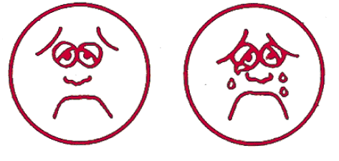
0 1 2 3 4
Not at all Very much

3. This is what you said was hard to do because of the problem.
Please write in the box below (add drawings if you want to).

4. How hard has it been to do this thing over the last week?
Please tick one box below.

0 1 2 3 4
Not at all hard Very hard

5. How have you felt this last week?
Please tick one box below.

0 1 2 3 4
Very good Very bad

6. Now that you are having therapy, you may find other problems have come up. If this has happened to you, please tell us what you are most worried about now or leave blank if you have no new worries.
Please write in the box below (add drawings if you want to).

7. How much has the new thing you’re worried about affected you over the last week?
Please tick one box below.

0 1 2 3 4
Not at all Very much

8. Compared to when you started therapy, how do you feel now?
Please tick one box below

0 1 2 3 4
Much better Much worse

Please use this space for any other comments/drawings or doodles

Thank you

Therapist Assessment Form – During-therapy

School ID Child’s gender M/F

Therapist ID Child’s age years

Child’s initials

Number of sessions attended so far: Group or 1:1:

Date during-therapy form completed (DD/MM/YY):

Comments – this box is provided for any comments you may want to record on the therapy so far.

Scoring
PSYCHLOPS Kids consists of three domains (Problems, Functioning and Wellbeing) which are scored. These are Q2 + Q4 + Q5. The maximum score for each question is 4 (scored 0-4), therefore total score range is 0 - 12. The change score is the difference between the total pre-therapy score and the total post-therapy score. Other questions provide useful qualitative information but do not contribute to the change score.

Total PSYCHLOPS Kids During Therapy score: _______

PSYCHLOPS Kids Version, June 2021. All rights reserved © 2021, Department of Psychology, Institute of Psychiatry, Psychology & Neuroscience, King’s College London; and Roundabout.

