A Questionnaire about You and How You Are Feeling

|  |  |
| --- | --- |
|  |  |

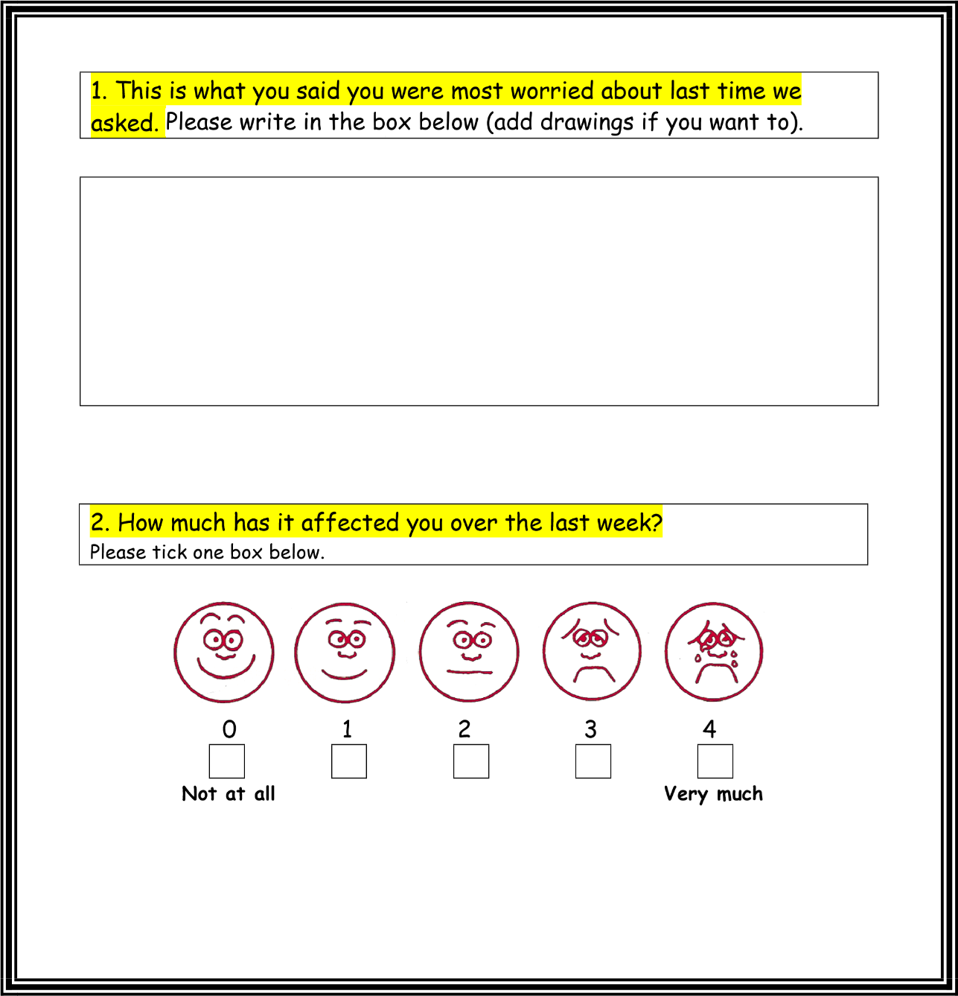You filled in a questionnaire before you started therapy. This is the follow up questionnaire that will help us see if anything has changed now that you have finished therapy. Please answer all the questions below and remember there are no right or wrong answers.

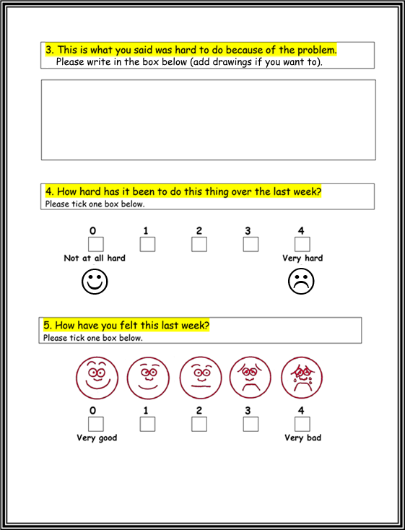

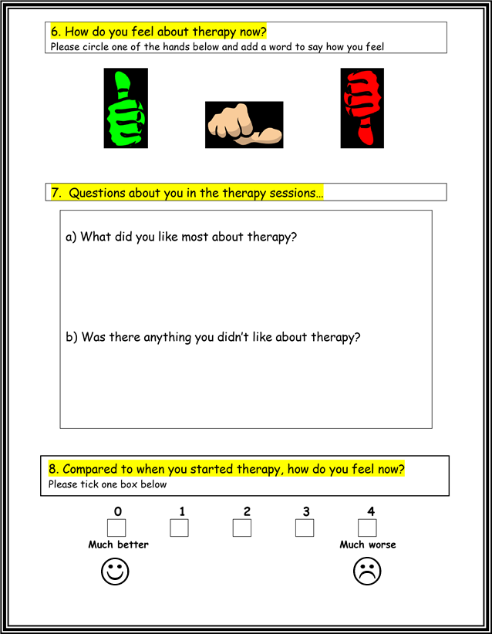

|  |  |
| --- | --- |
| Please use this space for any other comments/drawings or doodles                                                          **Thank you** |  |

|  |  |
| --- | --- |
|  |  |

# Therapist Assessment Form – post-therapy

**School ID Child’s gender M/F**

**Therapist ID Child’s age years**

## Child’s initials

**Number of sessions attended: Group or 1:1:**

**Date therapy ended** (DD/MM/YY)**:**

**Date PSYCHLOPS Kids Post-Therapy completed** (DD/MM/YY)**:**

# Validation question

**Now that the therapy has finished, how would you describe the child**

**overall?** *(Please tick one box below.)*

## 0 1 2 3 4 5

Much better better little better about the same worse much worse

## Scoring

PSYCHLOPS Kids consists of three domains (Problems, Functioning and Wellbeing) which are scored. These are Q2 + Q4 + Q5. The maximum score for each question is 4 (scored 0-4), therefore total score range is 0–12. Other questions provide useful qualitative information but do not contribute to the change score.

**Total PSYCHLOPS Kids post-therapy score: ______**

The change score is the difference between the total pre-therapy score and the total post-therapy score. The Effect Size can only be calculated by using a software package such as Excel to calculate a Standard Deviation.

*(mean pre-therapy score - mean post-therapy score )*

*The Effect Size = ----------------------------------------------------------------------------- Standard Deviation of the pre-therapy score****.***

PSYCHLOPS Kids Version, June 2021. All rights reserved © 2021, Department of Psychology, Institute of Psychiatry, Psychology & Neuroscience, King’s College London; and Roundabout