|  |  |
| --- | --- |
|  |  |

**For the Teacher/learning support staff or Therapist**

**How to use the PSYCHLOPS Kids Pre-Therapy form**

We hope that this questionnaire will help us to understand how the child is feeling. It is designed for children aged 7-13 years old. Please sit with the child as they fill out the form and support them to answer the questions for themselves**.** It should take no more than 10 minutes. Please explain to the child that outside of the school or therapy setting this questionnaire will be anonymous, i.e. this front sheet with their details will be removed from the rest of the form when the information is used for research and evaluation purposes.

**The Teacher/learning support staff or Therapist should fill this part in:**

**Teacher/learning support staff or Therapist’s name:**

**Name of School/Setting: Child’s gender: M/F**

**Child’s name: Child’s age:**

**Child’s Ethnic Group: Child’s first language:**

**ETHNIC**

**DEFINITIONS**

|  |  |  |  |  |  |  |  |  |
| --- | --- | --- | --- | --- | --- | --- | --- | --- |
| Bangladeshi | Asian - British | Indian | Pakistani | Asian - Other | Black -  African | Black - British | Black -  Caribbean | Black - Other |
|  |  |  |  |  |  |  |  |  |
| Chinese | Latin  American | Middle Eastern | White - British | White -  Irish | White -  European | White - Other | Mixed  Ethnicity | Refused to say |
|  |  |  |  |  |  |  |  |  |

**Date PSYCHLOPS Kids Pre-Therapy completed:**

**Scoring**

PSYCHLOPS Kids consists of three domains (Problems, Functioning and Wellbeing) which are scored. These are Q2 + Q5 + Q7. The maximum score for each question is 4 (scored 0-4), therefore total score range is 0 -12. The other questions provide useful qualitative information but are not used for scoring.

**Total PSYCHLOPS Kids Pre-Therapy score: _______**

PSYCHLOPS Kids Version, June 2021. All rights reserved © 2021, Department of Psychology, Institute of Psychiatry, Psychology & Neuroscience, King’s College London; and Roundabout.

# A Questionnaire about You and How You Are Feeling

|  |  |
| --- | --- |
|  |  |

Please answer all of the questions. There are no right or wrong answers. If there is something you don’t understand then please ask. After this form is completed, it will be given to your therapist. We will ask you to fill in another form like this near the end of your course of therapy.

Therapy sessions give you a place to think about the things that might be difficult in your life

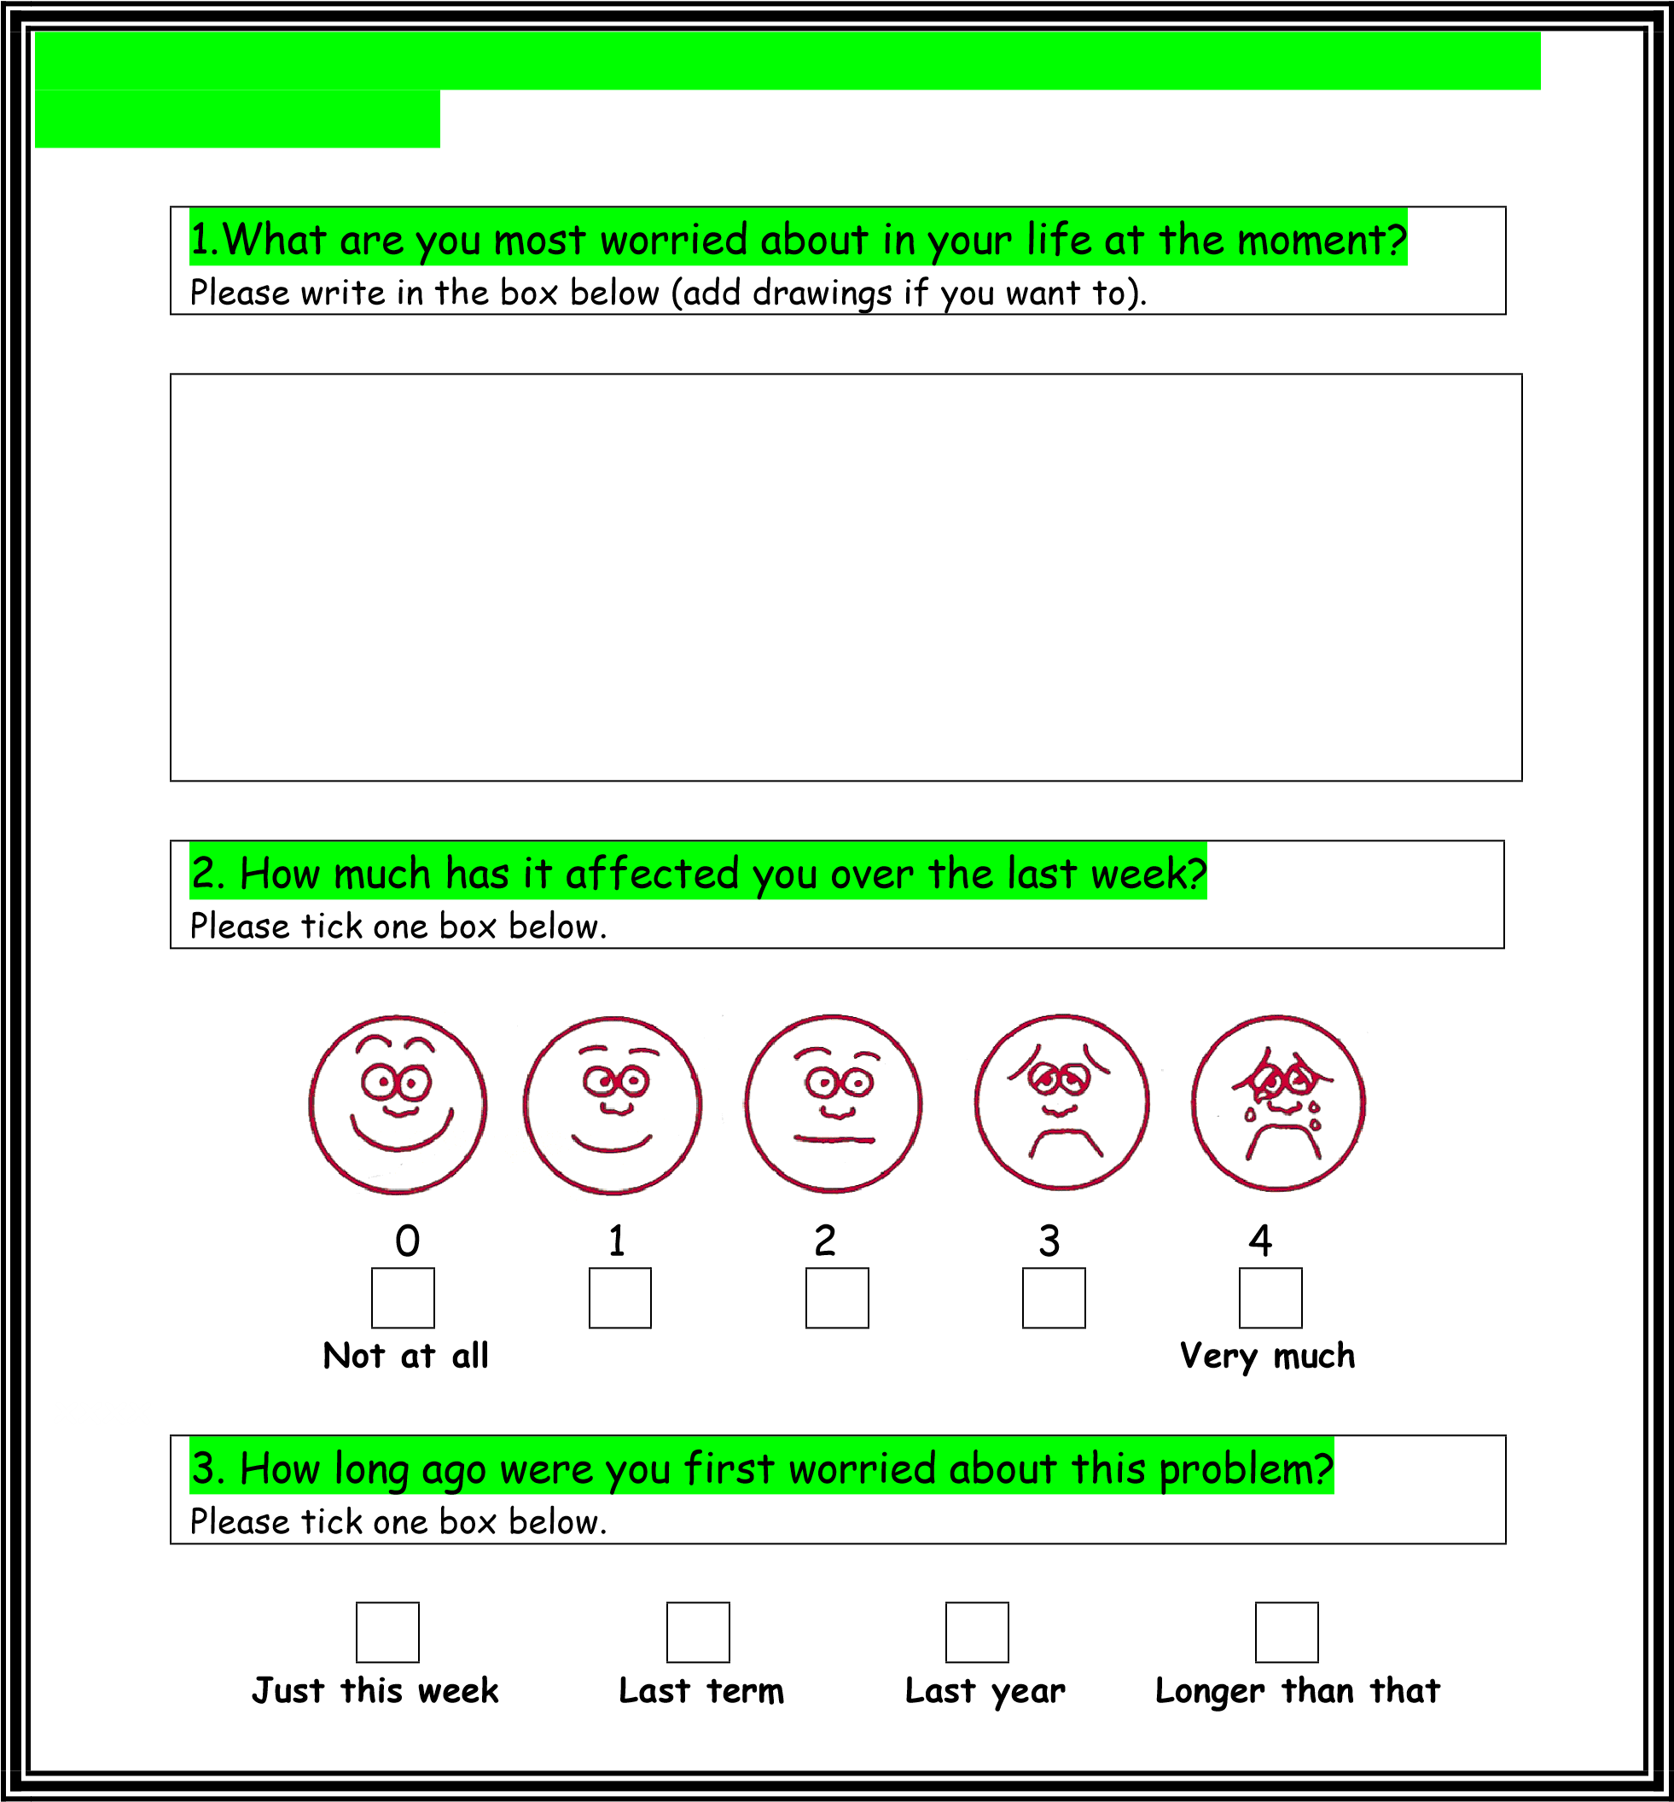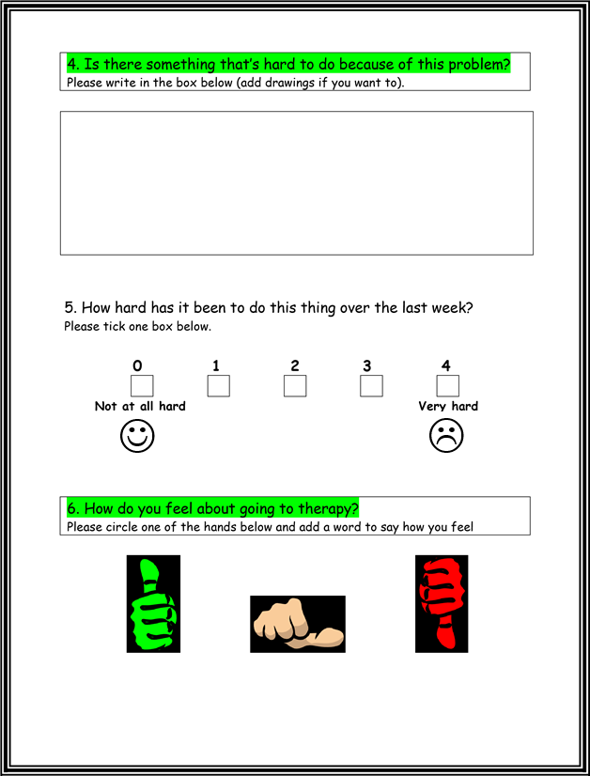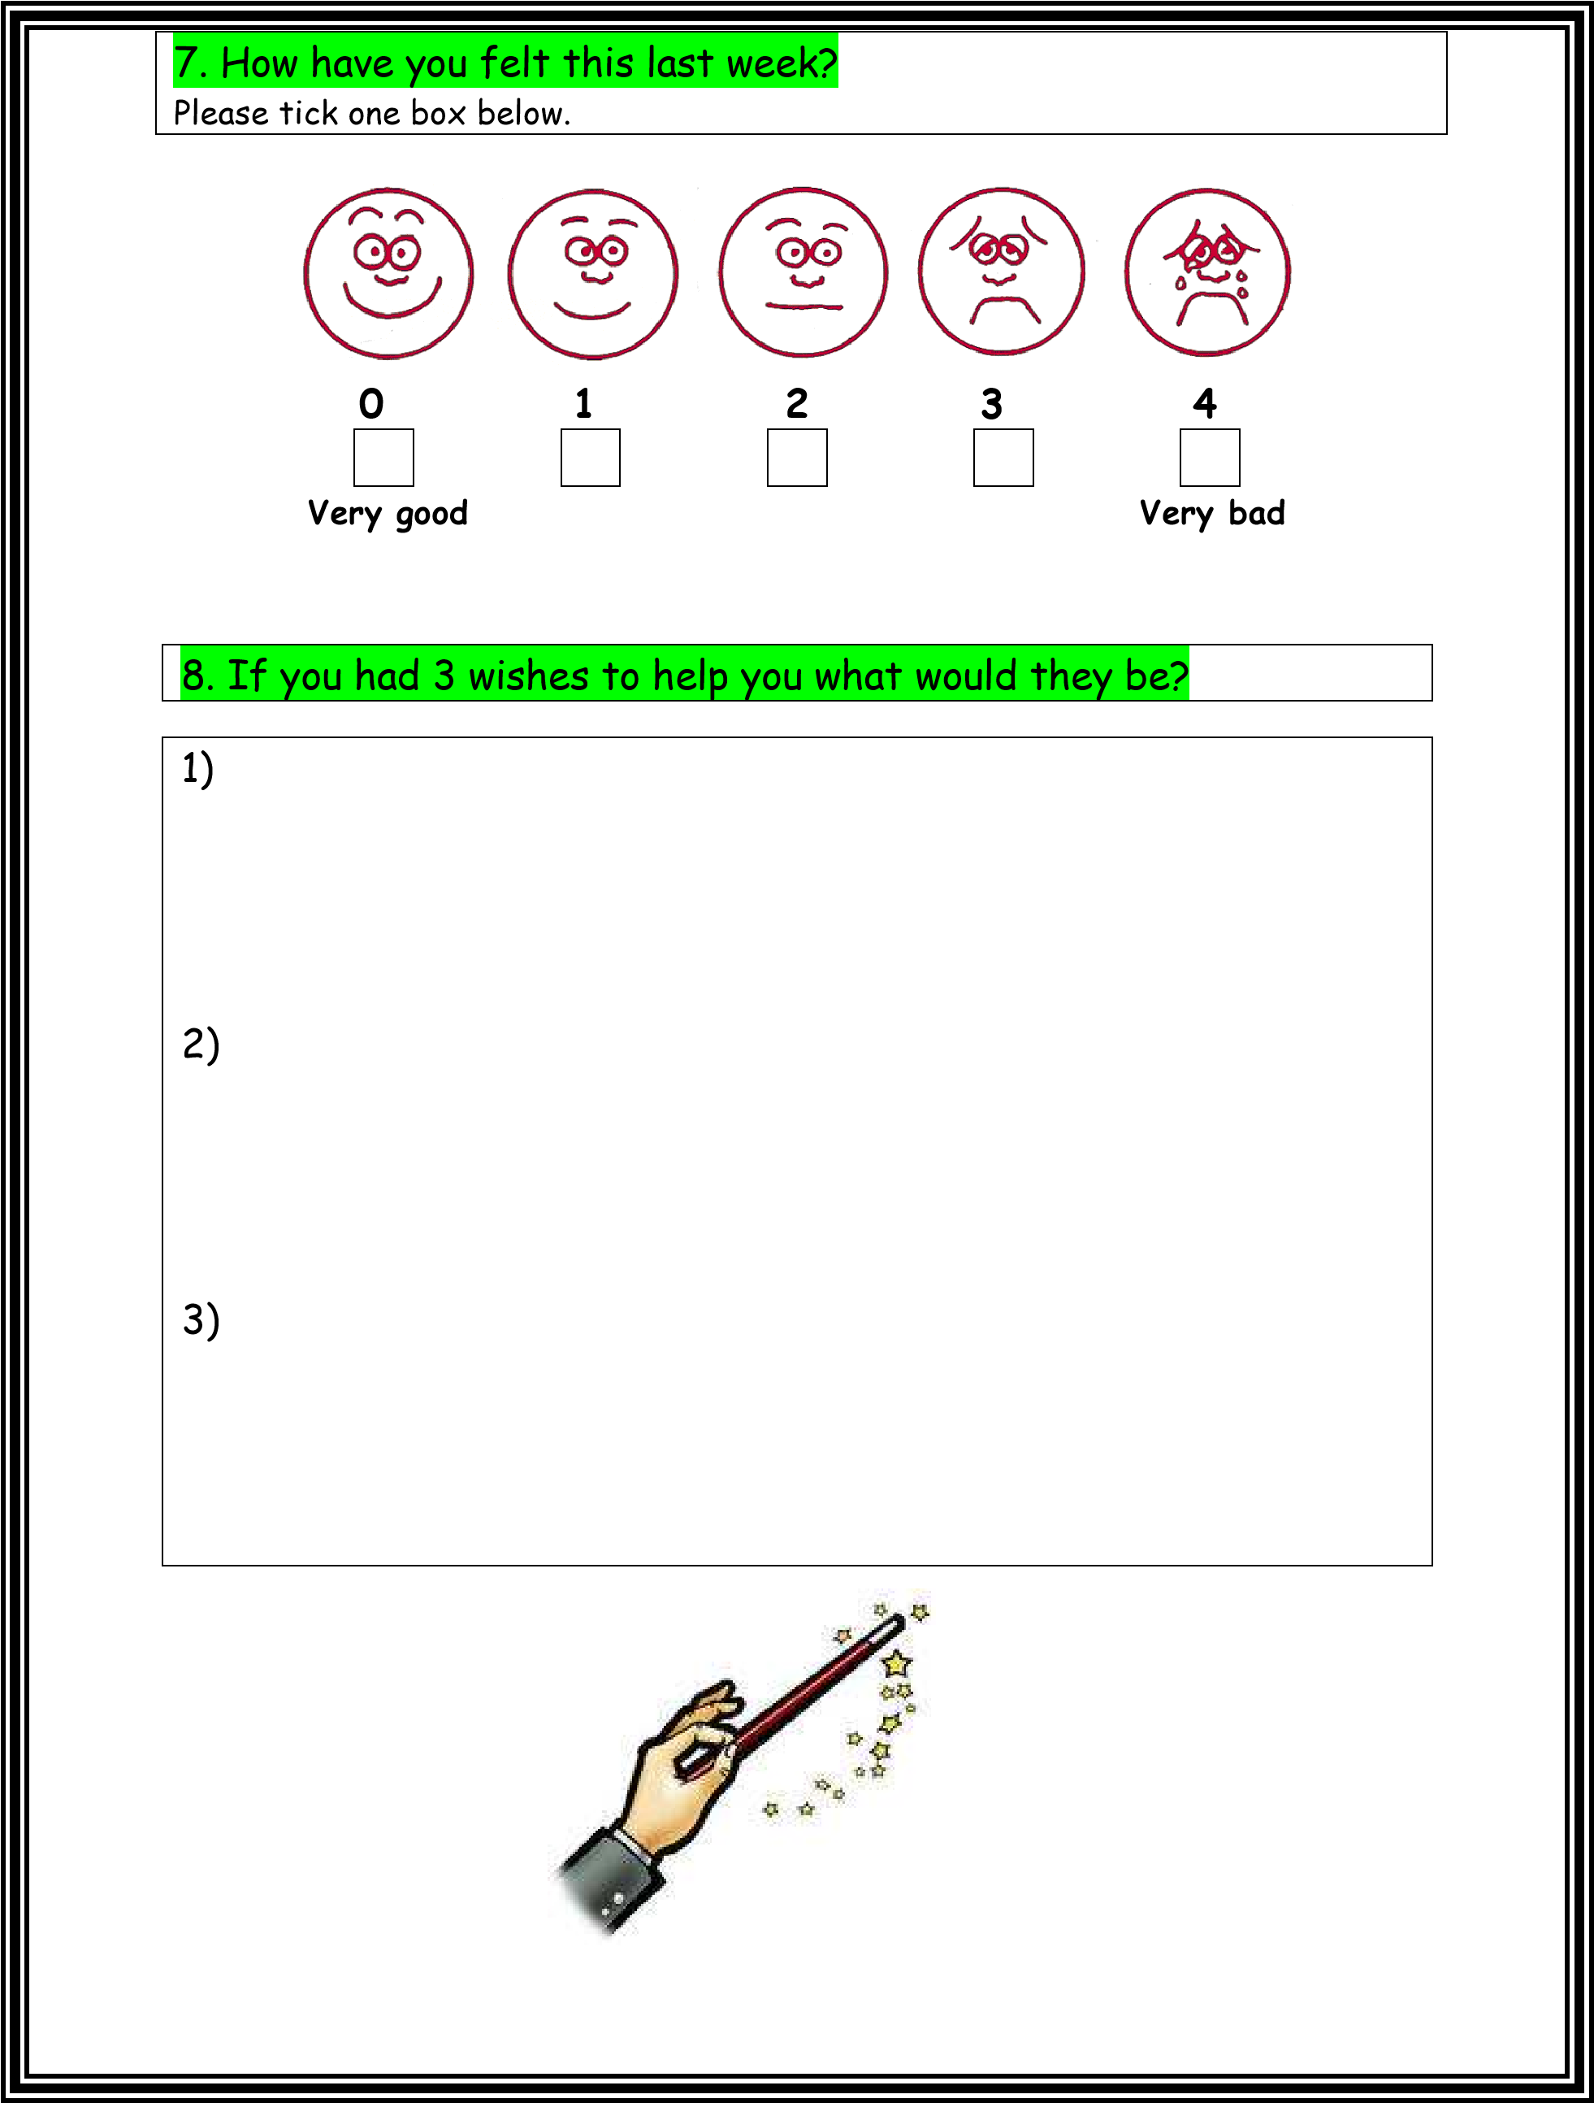

|  |  |
| --- | --- |
| Please use this space for any other comments/drawing/doodles                                                                  **Thank you** |  |