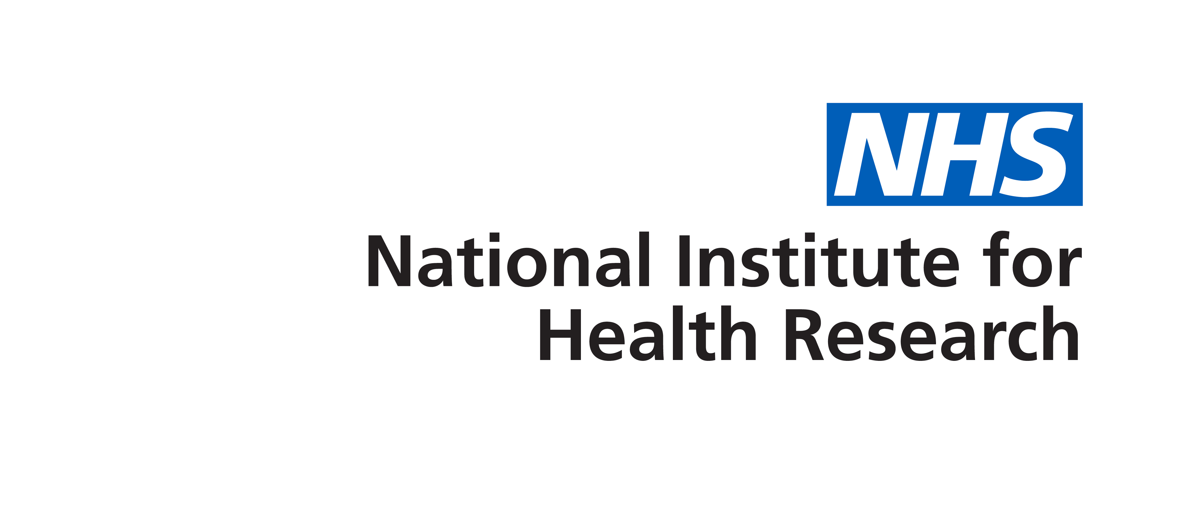

Young Person’s Mental Health Advisory Group Application Form

Interested in becoming a member? Use this form to tell us more about you and why you would like to be a part of the Young Person’s Group.

The Young Person’s Mental Health Advisory Group will be made up young people aged between 16 and 25 with experience of mental health issues.
The primary purpose of the group is to help improve the quality of mental health research studies. Meetings will be held every 6-8 weeks and all reasonable travel expenses will be covered.
Your name
Your address
Your email address
Your telephone no
Date of Birth
Emergency Contact Details:
Name
Relationship
Number

Why are you interested in becoming a member of the Young Person’s Mental Health Advisory Group?
Do you have any relationships with any members or facilitators of the YPMHAG? If so, please describe
Based on your experience of using mental health services (GP, IAPT services, CAMHS, etc.) or supporting someone who has, please provide up to 3 suggestions as to how services could be improved
Please tell us about an idea for a research project which could help improve mental health services.
Is there any other information, experience or skills relevant to your application that you would like to share with us? If so, please use the box provided.

Our meetings cover a diverse range of topics - if there any topics which you might find unpleasant/distressing please list them here and we will alert you if they are on a meeting agenda.

Is there anything else you feel we should know to help facilitate your time with the group?

Please send completed application forms to:
ypmhag@kcl.ac.uk

Need more information?
Please contact:
Sara Simblett
sara.simblett@kcl.ac.uk

