King’s Apply for Joint A*STAR—King’s College London PhD Studentships in Biomedical Science

Create an account
- Before you start, you will need to log in to a King’s Apply account: https://apply.kcl.ac.uk/
  - Log in with your existing details, or
  - Register a new account
- Enter your data, check the box confirming agreement of the Terms and Conditions, and click “Submit”. At this point you will be sent an email confirming your login details. Please check your spam filter if this isn’t in your inbox and add us to your safe sender list.

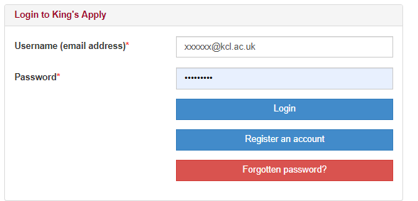

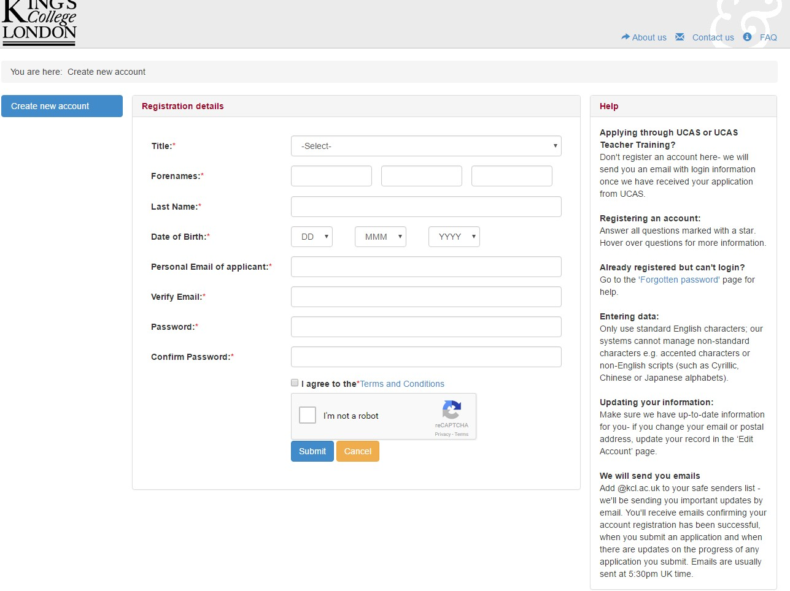

Start an application.
- Click ‘New Application’ where you will progress to the “Choose a Programme” screen.
- Select the programme to apply to (as shown in the image below):

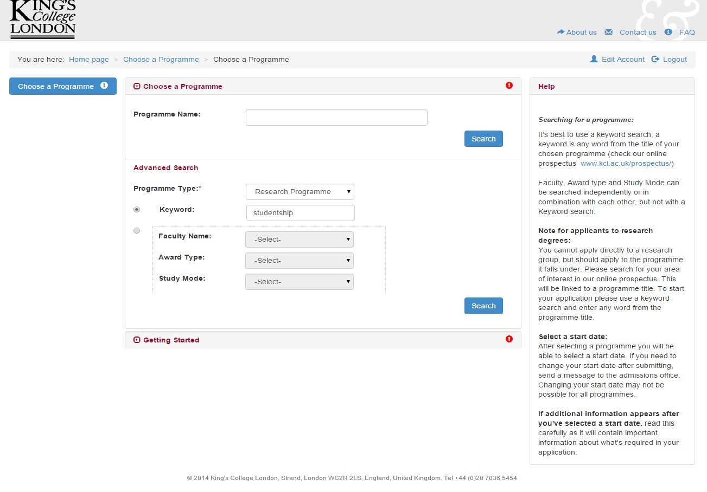

- Under Programme Name type ‘A*STAR and King’s College London Studentships’
- The A*STAR and King’s College London Studentships will be listed once the programme has been selected, please select the start date (only one date is available) and read the on-screen information about how to progress through the application. Please pay careful attention to the on-screen information; it is the applicant’s responsibility to submit all required documents.

Please be sure to complete the following sections of the form with all relevant information (all questions with an asterisk are mandatory and you will not be able to submit without answering these):

  - Personal Information*
  - Education*
  - Employment history* (you will be able to enter up to five sets of employment information)
  - CV*: upload a PDF copy of your CV as an attachment to the Employment History Section.
  - The ‘Nature of work’ field allows only 50 characters, but you can upload further employment information on the references screen
  - Personal statement*. Please include your personal statement in this section. You should type your personal statement directly into the Personal Statement free text box (Personal Statements uploaded onto the application as a separate PDF will not be accepted). There is a 4000 character limit, so please ensure that any text you plan to copy and paste into the box is within these limits (you should note that the Personal Statement character limit includes punctuation and spaces and so may differ from the character count in your source text).
  - References*: Contact details for two academic referees or relevant employers in research institutions/companies (we will then contact your referees directly). To avoid any conflict of interest, please do NOT name as a referee any supervisor whose project you are likely to choose from in the project catalogue. References from prospective supervisors will be discounted, and therefore disadvantage your application.
  - Funding*: In the funding section of the online application form please enter the funding code that corresponds to the theme in which your first-choice project is listed (see drop down menu below for all funding codes).
  - Research Proposal*: In the research proposal section, please enter the funding code that corresponds to the theme in which your first-choice project is listed as the ‘Project Title’ (see drop down menu below for all funding codes). Please list three projects of interest (from only the Project Catalogue) in order of preference in the free-text box under the Research Proposal section (see below drop down for an example).
  - Finally, check and submit your application.

Additional Support

Personal Statement

Your personal statement should include the following elements:
  - Why do you want to join this PhD programme?
Try to convey your enthusiasm and motivation for research. Do you understand the demands of postgraduate research?
  - Why have you chosen the three projects?
  - Why King’s College London?
  - What is the relevance of your first degree to this study?
Comment on relevance of courses you have taken at university. Point out any circumstances that may have affected your academic results, that you think should be considered.
  - What academic skills have you got to offer?
Knowledge of relevant scientific topics and techniques. Experiences of research projects you have done. Academic prizes you have been awarded.
  - What personal skills can you offer?
Demonstrate that you have considered your strengths and weaknesses for postgraduate research. Can you demonstrate the dedication and resilience required to complete a PhD?
  - What are your strengths?
In what ways are you better than other applicants?
  - What are your career aims?
Tell us your short-term aims and long-term career ambition.

References:
Your references must contain contact details for two academic referees or relevant employers in research institutions/companies (we will then contact your referees directly). Note that academic referees must have university email addresses and employer references should have the official email address of the company (Gmail, Hotmail etc. addresses are not acceptable). If you already have two academic references, you can scan and upload these to the online application instead (note that they must be signed and on headed paper). Please remember that it is your responsibility to ensure we have received the references by application deadline; ensure to start your application before the deadline and contact your referees to let them know we will be requesting a reference from them.

NOTE: referees will only be contacted once an application is submitted.

Funding
In the funding section of the online application form please enter one of the following codes that corresponds to the theme in which your first-choice project from the A*STAR and King’s College London Project Catalogue listed:

- Cells, Molecules and the Basis of Health and Disease: THEME1_2023
- Neuroscience and Mental Health: THEME2_2023

For example, if your first-choice project falls under Theme 2: Neuroscience and Mental Health, the code that you should enter is “THEME2_2023”.

**Only projects listed in the October 2023 Entry Catalogue are available for funding.

Research Proposal

Project Title: Insert funding code: e.g., “THEME2_2023”.

State your three preferred PhD projects from the Project Catalogue from the list of PhD projects on offer for 2023/24. These should be listed in order of preference, and you should include the number that is assigned to the project and the project title. Please list these in the free-text box under the Research Proposal section of the application, for example:
1.1 ‘’Project Title’’
2.1 ‘’Project Title’’

Contact Us
If you have any questions about the application process, please get in touch with the Centre for Doctoral Studies: doctoralstudies@kcl.ac.uk

For queries relating specifically to King’s Apply, please contact the Admissions Department.

