Admissions complaints procedure for applicants to King’s College London

Admissions

Admissions & Registry Services

Approved: April 2016
Review date: March 2018
Minor Amends re Appendix 2: October 2016

Version 1.1

Contents
1. Purpose 4
2. Scope 4
3. Complaints made without foundation (frivolous), in bad faith (vexatious) or anonymously 5
4. Victimisation: declaration of intent 5
5. Resolution of a complaint 5
6. Confidentiality and record keeping 5
7. Timescales 6
8. Informal local resolution 6
9. Stage One Complaint to the relevant department head 7
10. Stage Two Complaint to the Director of Students and Education 7
Appendix 1: Flow diagram of complaints procedure 9
Appendix 2: Applicant Complaint Form (ACF) 10

1. Purpose

  - King’s College London is committed to ensuring that all applications are considered on their individual merits and treated in a fair and equal way, utilising an holistic approach, based on all information provided to the university through the application process. It is also committed to providing high quality and responsive services to all applicants as they make an application to King’s College London.

  - However, it is recognised that there may be occasions where applicants feel that the university has not met the high standards that it sets itself. This document defines the procedure through which applicants to King’s College London can make a complaint regarding the level of service received from the university in the application process.

2. Scope

2.1 This procedure is for applicants who wish to make a complaint to the university regarding the application process. In the context of this procedure, a complaint is defined as an expression of dissatisfaction with the service provided by the university to the applicant during the application process.

2.1 This procedure is not appropriate for:
- Applicants who wish to appeal a decision;
- Applicants seeking detailed feedback on an application;
- Applicants seeking a reconsideration of the academic or professional judgement made by Admissions Tutors or Admissions Office staff;
- Applicants who receive an offer of admission but who subsequently decline that offer, or are deemed to have declined an offer by failure to respond by a set deadline or with the required deposit (if applicable);
- Applicants who wish to declare mitigating circumstances which may be taken into account when considering an application.

2.2 Separate procedures are in place for:

- applicants wishing to obtain detailed feedback on their application;
- applicants wishing to declare mitigating circumstances.
- applicants wishing to appeal a decision based on misapplication of the general entrance requirements, the King’s Fair Admissions Policies, and/or the specific entrance requirements of the programme of study or other significant administrative or procedural error(s) affecting the outcome of the application;

If the university deems that an issue raised under the complaints procedure falls within the scope of an alternative procedure as listed above, the university reserves the right to move the issue to the more appropriate procedure to ensure it is dealt with in the best way. The applicant will be informed of this.

2.3 The complaints procedure has one informal and two formal elements:
- Informal local resolution, dealt with at the most local relevant level (for example an issue that is raised in a telephone conversation with a member of staff at the Admissions Office such as a delay in the response to a King’s Apply message. The message is reviewed by the Admissions Office staff and the issue can be resolved during the course of the conversation.);
- Stage One Complaint: formal written complaint investigated by the Head of Undergraduate or Postgraduate Admissions or where the programme is not administered by the Admissions Office, by the Head of the academic department responsible for the admissions decision;
- Stage Two Complaint: if the applicant is not satisfied with the outcome reached as a result of the Stage One Complaint, they may escalate the complaint to be investigated by the Director of Students and Education (or nominee).

A flow diagram of the complaints procedure can be found in Appendix 1.

3. Complaints made without foundation (frivolous), in bad faith (vexatious) or anonymously

3.1 Examples of frivolous or vexatious complaints include the following:
(a) complaints which are obsessive, harassing, or repetitive;
(b) insistence on pursuing complaints without merit and/or unrealistic, unreasonable outcomes;
(c) insistence on pursuing what may be meritorious complaints in an unreasonable manner;
(d) complaints which are designed to cause disruption or annoyance;
(e) demands for redress which lack any serious purpose.

3.2 The university may terminate consideration of a complaint if it considers it to be without foundation or made in bad faith. In such instances the member of staff dealing with the complaint will write to the applicant to explain why consideration of the matter is being terminated.

3.3 Anonymous complaints will not be considered.

4. Victimisation: declaration of intent

4.1 Subject to the above, the university undertakes that any applicant seeking to use this procedure will not be treated less favourably in the application process, any future applications that they may make to King’s College London, or any other aspect of university life, as a result of action taken to pursue an alleged complaint.

5. Resolution of a complaint

5.1 Where a complaint is upheld in whole or in part, possible outcomes may include an apology, a clear explanation of the events or context that led to the incident in question, a change in procedures to ensure that the circumstances do not recur, referral of the complaint for consideration under another university procedure or a combination of these or other outcomes.

6. Confidentiality and record keeping

6.1 The university will seek to do all within its power to limit the disclosure of information consistent with conducting a fair investigation and the implementation of any recommendations following investigation into the complaint. However, if an applicant names another member of the university (including student ambassadors and oversees agents), then the person(s) named will normally have the right to know the complaint made against her/him in order to be able to reply to the complaint. This is consistent with the duties owed to the university’s staff and students.

6.2 Once an applicant has made a Stage One Complaint, records will not be held on the application but kept securely in the Admissions Office. Records will be retained in accordance with the university’s obligations under the Data Protection Act 1998. Original copies of formal complaints must be sent to the Student Conduct & Appeals Office at the conclusion of the case.

7. Timescales

7.1 This procedure outlines timescales within which the university and the applicant aim to work. Only in exceptional circumstances and at the discretion of the Head of Undergraduate or Postgraduate Admissions or Head of academic department will the university accept complaints from applicants outside these timescales. The university endeavours to respond within the timescales outlined, but unfortunately this may not always be possible. In some cases an investigation may take longer than usual to ensure that all of the issues raised have been appropriately addressed. In addition there may be circumstances beyond the university’s control, such as a relevant member of staff being away from the university, where it may not be possible to adhere to the timescales it has set for itself and still carry out a proper investigation. Any delay will be communicated to all parties involved in the complaint.

7.2 The applicant should raise the complaint at the earliest opportunity and in any case in respect of Stage One no later than 10 working days from the applicant being aware of the incident or sequence of events giving rise to the complaint. To raise a Stage One Complaint, the applicant is required to complete an Applicant Complaint Form (ACF) (Appendix 2) and submit this to the King’s Admissions Office via email to admissions.confidential@kcl.ac.uk. Admissions staff will confirm receipt of the completed ACF no later than 10 working days following submission. The Head of Undergraduate Admissions or Head of Postgraduate Admissions or Head of academic department will respond to the applicant’s complaint no later than 20 working days after the confirmation of receipt of a fully completed ACF.

8. Informal local resolution

8.1 In the interest of providing the best possible service to applicants, the university emphasises the importance of seeking a resolution to a complaint regarding an application through informal discussion with the university at the earliest opportunity to avoid a protracted investigation.

8.2 Informal complaints are permitted to be made by applicants. Third parties are not permitted to make a complaint on behalf of an applicant, unless the applicant provides explicit written permission.

8.3 Informal complaints may be made to a member of staff at the university such as Admissions Officer or Marketing Officer, as a first point of contact in writing, by email or verbally.

8.4 The relevant member of staff will endeavour to assist the applicant making the informal complaint and if at all possible find a swift resolution to this. An informal complaint may be escalated to a more senior member of staff, such as an Admissions Manager, if further expertise is required to find a resolution.

8.5 A note on the application will be made when an informal complaint is made to keep a record of the incident. This will have no bearing on decisions made regarding the applicant’s application or future applications as noted in Victimisation: declaration of intent.

8.6 If the outcome of the informal complaint is that no resolution can be agreed to the satisfaction of the applicant, the applicant will be made aware of the Stage One Complaint procedure.

8.7 Although not obliged, the applicant making a complaint would normally be expected to wait for the outcome of the informal local resolution before making a formal Stage One Complaint. The relevant member of staff dealing with the local informal complaint may themselves wish to refer the applicant to Stage One, should they feel that the matter requires a more thorough investigation or the complaint appears to be particularly complex. If the applicant does not agree to submit a Stage One formal complaint this will be determined as being is the end of the matter as far as this procedure is concerned.

9. Stage One Complaint to the relevant department head

9.1 Should a complaint not be dealt with informally to the satisfaction of the applicant she/he may initiate a Stage One Complaint. It is also permissible to submit a Stage One Complaint without seeking an informal resolution. The Stage One Complaint procedure involves an investigation by the Head of Undergraduate or Head of Postgraduate Admissions or, if the programme is not administered by the Admissions Office, by the Head of academic department. If the complaint relates to a senior member of King’s Admissions Office staff, the complaint will be reviewed by a senior colleague outside of Admissions and Registry Services.

9.2 To initiate a Stage One Complaint, the applicant must submit a completed Applicant Complaint Form (ACF) (Appendix 2) to the King’s Admissions Office within 10 working days of the incident. Third parties are not permitted to make a Stage One Complaint on behalf of an applicant, unless the applicant provides explicit written permission. The university will only accept a complaint submitted after this deadline in exceptional circumstances, and at the discretion of the Head of Undergraduate Admissions or Head of Postgraduate Admissions or Head of academic department.

9.3 The King’s Admissions Office will confirm receipt of the completed ACF within 10 working days of submission.

9.4 The Head of Undergraduate Admissions or Head of Postgraduate Admissions or Head of academic department or her/his nominee will normally have up to 20 working days from the date of confirmation of receipt of the completed ACF to investigate and respond in writing to the applicant. The ACF will outline the nature of the complaint, steps that have been taken to resolve the issue to date, the timings involved to date and how the applicant wishes to see the complaint resolved.

9.5 The investigation will include looking into the circumstances of the complaint as well as whether or not any members of staff involved followed published procedures. The investigation may involve interviewing the applicant and other persons directly involved. The person charged with investigating the complaint may seek opinion and information from any person with an interest in, or knowledge of, the matter being complained about.

9.6 At the conclusion of the investigation the Head of Undergraduate Admissions or Head of Postgraduate Admissions or Head of academic department will form a judgement on the merits of the complaint and the applicant will be informed in writing of her/his findings. The findings will include the judgement regarding the merits of the complaint and, if applicable, proposals for a resolution of the complaint and/or recommendations for further action arising from the complaint. The applicant does not have the right to receive details of the actions taken against any third party as a result of the complaint as consistent with the duties owed to the university’s staff and students. The communication will also inform the applicant of the right to submit a further complaint under Stage Two of this procedure if she/he remains dissatisfied with the findings.

10. Stage Two Complaint to the Director of Students and Education
10.1 Where an applicant’s complaint to the Head of Undergraduate Admissions or Head of Postgraduate Admissions or Head of academic department is not upheld or a satisfactory outcome is not reached, the applicant may apply to the Director of Students and Education (or nominee) for further investigation. Stage Two Complaints must be received in writing to the Student Conduct & Appeals Office to the email address appeals@kcl.ac.uk within 10 working days of the Stage One Complaint response from the Head of Undergraduate Admissions or Head of Postgraduate Admissions or Head of academic department. The university will only accept a complaint submitted after this deadline in exceptional circumstances, and at the discretion of the Director of Students and Education (or nominee).

10.2 A Stage Two Complaint may be allowed, at the discretion of the Director of Students and Education (or nominee), on the following grounds:
a) if, in the view of the Director of Students and Education, there is evidence of significant administrative or procedural error in the processing of the Stage One Complaint.
and/or
b) if, in the view of the Director of Students and Education, there is new evidence which the applicant was unable to provide as part of the Stage One Complaint.

10.3 The Director of Students and Education (or nominee) will normally acknowledge receipt of the Stage Two Complaint within 10 working days, and respond to the appeal within 20 working days of receipt. The response will indicate whether, in the opinion of the Director, one or both of the criteria above are satisfied.

10.4 Where a complaint is upheld (fully or partially), the Director of Students and Education (or nominee) will inform the King’s Admissions Office or the relevant academic department as to any actions to be taken. The Director of Students and Education’s response to the applicant will be copied to the Director of Admissions and Registry Services. Any further actions or reconsideration to be taken will be communicated to the applicant directly via the Admissions Office or relevant academic department within 10 working days of receiving the Director of Students and Education’s decision.

10.5 The Director of Students and Education’s decision is final and no further appeal or review is permitted.

Appendix 1: Flow diagram of complaints procedure

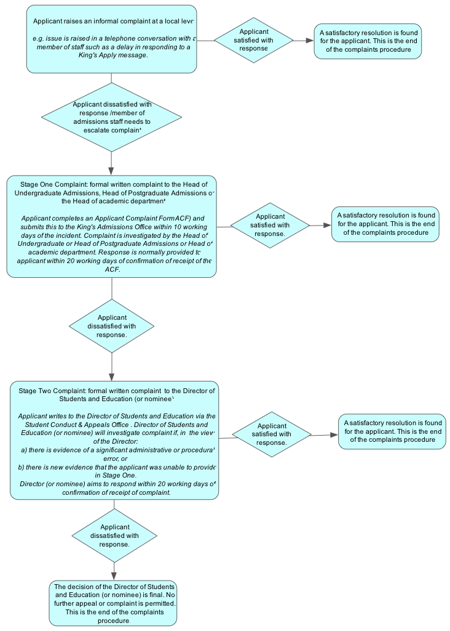

Appendix 2: Applicant Complaint Form (ACF)

Applicant Complaint Form

Stage One Complaint
When to use this Form
It is recommended that you attempt an informal resolution of your complaint at local level, for example with the relevant Admissions Officer, before initiating the formal Complaint process. However where you are not satisfied with local resolution and/or it has been recommended by a King’s representative that you formalize your concerns, please first consult the Applicant Complaints Procedure (as it contains important information about how the university will handle your complaint and the relevant timescales) and then complete this form to begin a formal Stage One Complaint.
Please note that this form should not be used to appeal application outcomes or to submit mitigating circumstances – there are separate processes for appealing or submitting mitigating circumstances, which may be found here:
- Appeals: www.kcl.ac.uk/aboutkings/orgstructure/ps/acservices/conduct/admissions-appeals.aspx
- Mitigating Circumstances: www.kcl.ac.uk/study/undergraduate/apply/policies-and-guidance/mitigating-circumstances.aspx
Completing this form
We can only accept a Form which is completed and signed by the applicant who is complaining. Any Forms submitted on behalf of an applicant should be accompanied by formal written consent from the applicant that you may submit on their behalf. For reasons of fairness, the university will not consider anonymous complaints. If your complaint names a member of university staff, they will normally have the right to know the complaint made about them in order to respond.
Please return the completed form within 10 working days of the incident arising to admissions.confidential@kcl.ac.uk
1. Application details
First name |  | Surname
Application Number (King’s number or UCAS number) |  | Email address

2. Application Details
Programme level | Pre-Sessional International Foundation Undergraduate Postgraduate
Programme name
Appeals must be submitted within 10 working days of the incident. Late complaints will only be accepted in exceptional circumstance and reasons for the delay should be stated below:

3. Complaint Summary
Please summarise your complaint in no more than 100 words. You will provide more detailed information later in this form, but this summary will help us understand the most important elements from your point of view.
4. Causing Factors
Please specify factors you consider to be the cause of your complaint – please tick those that apply
Service or facilities at the university | Yes No
Discrimination, harassment or bullying | Yes No
Action or lack of perceived action taken by a member of university staff | Yes No
Other, please specify below | Yes No

5. Your Complaint (detail)
Please set out the main points of your complaint, being specific as to key dates or contact names wherever possible. Please try and focus on factual statements as this will help us to understand your complaint more clearly. If you need more space you may continue on a separate sheet of paper, which should be securely attached to this form and clearly mark this with your name and King’s student number or UCAS Personal ID.

3. Supporting Evidence
Please list below each piece of documentary evidence you have submitted with this form

3. Previous Action
Please briefly explain what steps you have taken to resolve your complaint to date and why you are dissatisfied with the conclusion of any informal resolution. Please include as much detail as you can, such as dates and the names of any staff you have contacted
Action I have previously undertaken

Reason(s) as to why I was dissatisfied with the resolution

3. Desired Outcome
Please briefly explain what you would consider to be a satisfactory resolution to your complaint.

4. Declaration
I have read and understood the university’s Applicant Complaints Procedure
All information and documentation provided in/with this form is complete and represents an accurate and true reflection of the situation that led to my complaint.
I agree that my complaint may be disclosed to relevant members of the university to the extent necessary for any investigation and to inform the continual improvement of services provided by the university.
I authorise the Heads of Undergraduate/Postgraduate Admissions to consider this form and any relevant information held by the university to the extent necessary for the consideration of my complaint.
I give permission for the university to seek verification of the authenticity of any statements or evidence provided with this complaint.
Signed |  | Date
If you are writing on behalf of the applicant as their nominated UCAS contact please confirm your full name and relationship (e.g. parent/guardian)below:

Next Steps
We aim to acknowledge receipt within 10 working days, and provide you with a response to the appeal within a further 10 working days.
This response will state whether your appeal is upheld (partially or fully) or rejected, and the reasons why.
Accessibility and Advice

If you require this form in a different format, or a hard-copy sent to you please contact admissions.confidential@kcl.ac.uk or telephone the Admissions Enquiries service on +44 (0) 20 7848 7000

