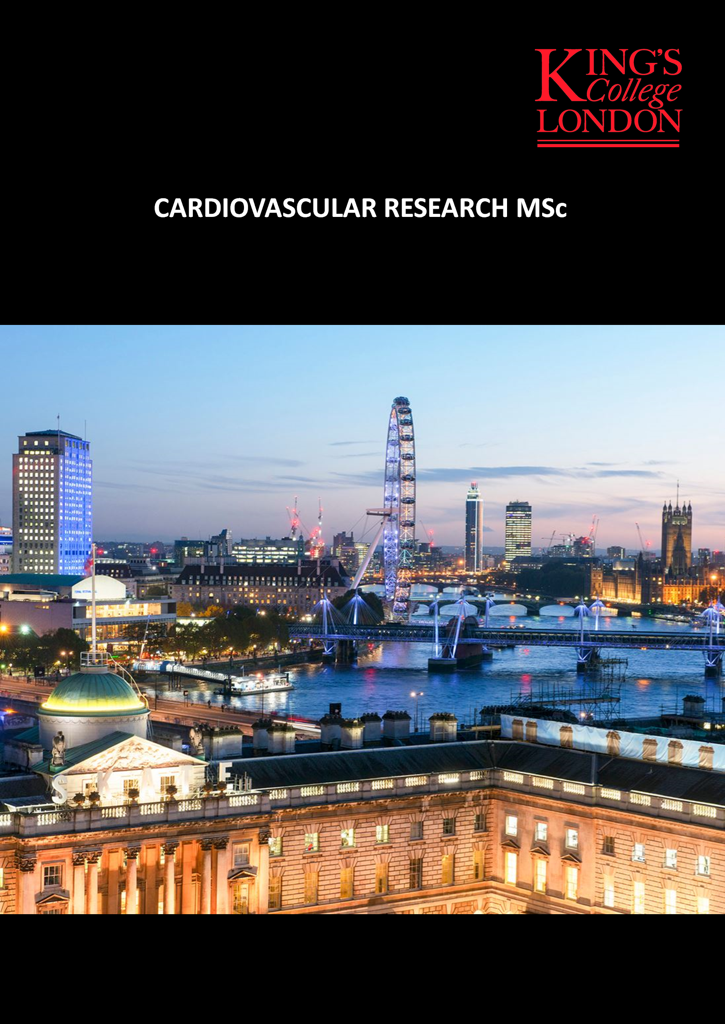

Faculty of Life Sciences & Medicine

Cardiovascular Division

MSc in Cardiovascular Research
TMSC1MTCVR
Handbook for 2016/17
Programme Director  Dr Paul Fraser  paul.fraser@kcl.ac.uk | Deputy Director  Professor Giovanni Mann  giovanni.mann@kcl.ac.uk
1. Introduction
Welcome to the MSc in Cardiovascular Research! The coming year will be challenging at times and occasionally you will find it difficult, but we trust that you will also find you will get a lot from it, that you will find it interesting, fun, and even inspirational. You will be allocated a personal Tutor, who will be able to advise you and guide you throughout the year.

Disclaimer
This handbook was published in September 2016, and reflects the information available at that time. We have endeavoured to make this information as accurate as possible and any changes will be communicated on the Cardiovascular Research MSc site in KEATS. If there is any conflict between information on the web page and this handbook, then the web page should be taken as the authoritative source. If you should find any information that you consider to be out of date, inaccurate or misleading then please contact Dr Fraser (paul.fraser@kcl.ac.uk ) with your reasons for considering the information to be inaccurate.
If you cannot find the information you require here it is likely to be in one of the other student handbooks.
Faculty Handbook. Additional useful information relating to your programme and to student welfare can be found in the Faculty Handbook: https://virtualcampus.kcl.ac.uk/vc/graduates/Default.aspx
King’s Student Handbook
The university has an online student handbook, covering useful College level information about services for students: http://www.kcl.ac.uk/aboutkings/quality/academic/myhandbook/index.aspx

Communication and Contacts
- All communication about changes to the programme timetable and/or content will be sent to you via your King’s email account and will also be notified on the programme’s KEATS entry.
- To aid communication between members of the class a WhatsApp group will be set up early in the programme.
- There is now a Facebook group that you are invited to join and communicate your comments.
- Two students will be elected to serve on the Staff Student Liaison Committee that meets once in each semester. The minutes of those meetings will be available on KEATS.

Programme Objectives
At the end of the programme students will be able to:
- Evaluate and assimilate the scientific literature in a given subject area and to think critically about the results and methods.
- Devise a hypothesis that can be tested experimentally.
- Analyse data, appreciate the value of reproducibility of data and draw valid conclusions.
- Collect data and apply appropriate methods to test a hypothesis.
- Develop an ability to comprehend and synthesise complex information.
- Organize a work-schedule, stick to deadlines, and prioritize activities.
- Communicate clearly and effectively, both orally and through writing.

Structure of the Cardiovascular Research MSc Programme
An MSc year needs to have 180 course credits cf. a BSc year of 120. This is made up of a research project of 90 cc (5-6 months), a Skills module of 30 cc, a Fundamental Cardiovascular Research Topics module of 30 cc and an Applied Cardiovascular Research Topics module of 30 cc.

Module name: | Module format: | cc
Cardiovascular Skills: 7MRV0012 | Workshops & 2h Exam | 30
Fundamental Cardiovascular  Research Topics: 7MRV0013 | 9 Lectures & 9 Seminars  1 Essay + 3h Exam | 30
Applied Cardiovascular  Research Topics: 7MRV0011 | 9 Lectures & 9 Seminars  1 Essay + 3h Exam | 30
Cardiovascular Research  Project: 7MRV0015  7MRV0016 | Laboratory project  Dissertation  Project performance | 60  30
 | Total: | 180

The MSc Pass mark is 50%. A Merit is awarded for ≥ 60% and a Distinction for ≥70%. Each module has to be passed.

The Modules

Cardiovascular Skills (7MRV0012: 30 cc)
This module will consist of 2 elements: workshops for essential skills and advanced techniques. There are also sessions on the use of statistics and scientific interpretation that will be followed by an examination in May. A basic knowledge of statistics is required for this component, and a self-directed teaching aid is available on KEATS for those who feel unsure of this.

Lectures & Workshops A workshop will consist of talks, with (where suitable) some interactive components such as demonstration, worked examples & hands-on experience. Currently the following topics are available: - tissue culture - Western blotting - Use of Animals – Experimental design and analysis - Scientific Interpretation - Leukocytes - Capillary Permeability - Flow cytometry – Skin – Histology - Heart failure - Artery stiffness – Animal Models of Heart Failure and Stroke – Angiogenesis – miRNA - Confocal Microscopy.
Assessment -Scientific Interpretation exam (55%: mandatory qualifying mark 40%) + 6 of the workshops (45%) assessed on a rolling basis. These 6 assessments will often consist of 4 to 6 short paragraphs in answer to questions that centre on the theoretical and practical aspects of the workshop. At least 5 of these must be passed at 50% with the 6th must be at least 40%.

Literature based modules

Fundamental Cardiovascular Research (7MRV0013: 30cc)
and
Applied Cardiovascular Research (7MRV0011: 30cc)
These modules will address a number of topics that are the focus of current interest in the field of cardiovascular biology. The topics consist of introductory lectures to support student-led seminar sessions that consist of PowerPoint presentations of original research papers, with an internal expert present for guidance, followed by formalized question and answer sessions. The student questioners are instructed to prepare their questions in collaboration with the presenter to generate a good discussion of the science. Both the presenter and questioner will be awarded marks depending on the quality of the discussion they lead. The seminar reading lists and running order of presentations will be sent to the students by email and will be available on the programme’s KEATS site.

Fundamental Cardiovascular Research Staff
Endothelial control of vasculature; R Siow; P Fraser
Endothelial Derived Hyperpolarization; P Fraser;
Capillary permeability; P Fraser;
Leukocyte Transmigration; A Ivetic; P Fraser
Platelet signalling & Thrombogenesis; G Passacquale; P Fraser
Angiogenesis & Vascular Development; A Smith; P Fraser
Control of Heart Rate & Rhythm; M Shattock; P Fraser
Control of cardiac contraction; I Smyrnias; P Fraser
Redox Signalling; A Brewer; P Fraser
Assessment (30cc): Presentation and discussions (30%; mandatory qualifying mark 50%), 1h timed essay (15%; mandatory qualifying mark 40%) and a 3 question, 3 hour examination (55%; mandatory qualifying mark 40%) taken in May.

Applied Cardiovascular Research Staff
Myocardial signalling and hypertrophy; R Heads; P Fraser
Hypertension; A Ferro; P Fraser
Atherogenesis; C Shanahan; P Fraser
Acute coronary syndromes/MI; D Perera; P Fraser
Heart Failure & Cardiac Remodelling; I Smyrnias; P Fraser
Cardiac Regeneration – Stem Cells; L Zeng; P Fraser
Diabetes and Cardiovascular Disease; L Gnudi; P Fraser
Stroke; P Fraser;
Aneurysms; A Smith; P Fraser
Assessment (30cc): Presentation and discussions (30% core; mandatory qualifying mark 50%), 1 x 3,000 word essay after the Christmas vacation (15%; mandatory qualifying mark 40%) and on a 3 question, 3 hour examination (55%; mandatory qualifying mark 40%) taken in May.

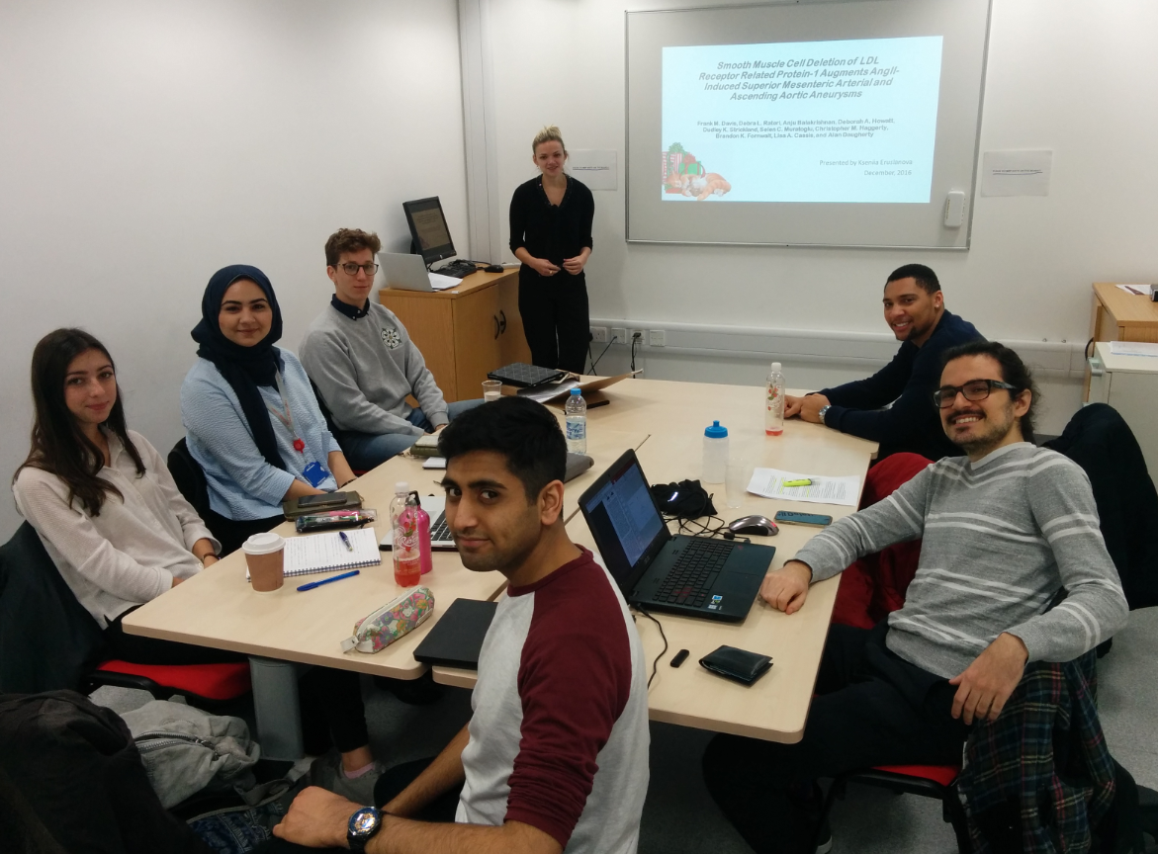

Photo taken during the student-led seminar on aortic aneurysms in December 2016

Notes on Seminar Presentation
The seminars are aimed to help you learn the subject matter by having a good discussion on and around the topic outlined by the reading list. It is important that certain ground rules are observed so that your presentations are understood and enjoyed by your audience.
Each paper should be presented in terms of:-
AIMS The authors will have had to justify the reasons for carrying out their experiments, you should mention these and place the work into some context.
METHODS The main methods should be very briefly outlined so that the audience can easily understand what really went on in the experiments. A simple diagram of the apparatus and/or the experimental procedures might be helpful, and is sometimes essential. Do not be over elaborate. The methods for individual experiments are often best presented with the results.
FINDINGS The crux of the presentation. You should present carefully selected graphs, and possibly tables, to emphasise the points you (or the authors) wish to make. Any scientist publishing a paper realizes that the best way to get a message across is in terms of a graph, and often considerable care will have been taken in deciding how best to present the data. There is no need to present the full content of the paper, just those elements that you think are really important.
DISCUSSION Have the authors achieved their declared objectives? Are there possible alternative interpretations of their results? What is the net contribution to the subject of this piece of work? You will appreciate that you have to know the papers to a considerable depth to be able to present them well. It is not the intention that you read your notes. It is far, far better that you talk fluently to the class, and refresh your memory from time to time by glancing at a crib sheet. In that way whatever you say will be part of a conversation, and allow your personality to come across. A reading will be dry and stilted, far removed from ordinary human expression.
DESIGNATED QUESTIONERS
You must of course read the paper first! Your questions should be based on whether you think that the authors have really shown what they have claimed, could there be other alternative (and perhaps better!) explanations for their results, and even suggest a better experiment. You are encouraged to collaborate with the presenter and the others with an aim to generate as good a discussion as possible.
SEMINAR ASSESSMENT
Your performance in the seminars will be assessed equally on the quality of the presentation and on the quality of the discussion generated by intelligent and thoughtful questions. The presenter and the questioners are encouraged to work as a team to produce a good performance and will share the (marks) benefits of a good session. Free questions (those that are outside a designated presentation) are very much encouraged and will attract bonuses!

Cardiovascular Research Project (7MRV0015: 60 cc & 7MRV0016: 30 cc)

The project forms half of the programme and should be the equivalent of 6 months full-time work. This means that you should spend around 4-5 months in the lab and the remaining time should be spent on reading the literature, data analysis and writing the dissertation.

At the end of the project students should be able to:
- Design and carry out appropriate experiments to test a hypothesis.
- Interpret results and summarise main findings (conclusions).
- Carry out statistical analysis on data.
- Keep professional records of work done.
- Manage time effectively.
- Develop problem solving and trouble shooting skills.
- Have the ability to work easily and competently in a laboratory environment.
- Analyse data critically and effectively.
- Write up a research dissertation.
At the end of the project and assessment phases students should have developed research skills to a postgraduate standard.

Project Supervision
The project supervisor should spend time at the start of the project discussing the suggested topic, background reading, practical considerations, and timetabling. The supervisor will also take the necessary steps over Animal Licence, Ethical Committee permission, and safety regulations where relevant. You should ensure that you understand the details of each of these, as they have important legal and safety implications. Remember that you are ultimately responsible for everything you do associated with the project, from your own safety, to proper attention to legal requirements over experimentation, and care of animals and human subjects. The Home Office specifies that students must receive training in animal experimentation before applying for a Personal Licence for animal work. This training is organised by King's if necessary.
The project supervisors are asked to help in the following ways:
- encourage the student to plan the protocol and draw up the design of experiments.
- give assistance with learning how to calibrate, check and use equipment. You should understand the theory behind any apparatus used for your project work, not just its method of operation.
- give practical help initially during experiments, but thereafter encourage the student to work independently as much as possible.
- provide overall supervision of the student's work, with particular attention to regulations and safety.
- provide some key references, and suggest where to find recent information.
- give guidance on analysis and presentation of data and on the most appropriate statistical tests for the data generated.
- read and give constructive criticism of one, and no more than two, draft versions of the dissertation. The dissertation has to be the student's own work.
- give relevant information about the conduct of the project to the Examiners, e.g. any problems encountered, unavoidable delays, equipment faults, availability of subjects/animals, extent to which student worked alone or as part of team, extent of assistance required. Supervisors will be asked to complete report forms after reading the dissertation, and these will be forwarded to the Examiners.

Project
The starting date for the project depends on your other coursework commitments and timetable, but should be as early as possible.
Timetable:
Early October: Project Titles distributed. Discuss options with programme co-ordinator
Mid-October: e-mail project preference (4 projects) to the programme co-ordinator
(paul.fraser@kcl.ac.uk)
Early November: Announcement of preliminary allocation. Contact prospective supervisor and/or (if needed) discuss options with programme co-ordinator. Please provide a 1 page CV and short (no more than ½ page) statement to the programme co-ordinator and prospective supervisor describing why you wish to do this project.
Mid November : Confirm project choice & start literature search

January-July 2016: Experimental work on project. You should write up sections as you go along (Introduction, Methods, Results, Reference list), leaving only the Discussion and Abstract to complete after the end of experiments.

End July 2016: Draft dissertation to project supervisor for comment and correction. Your supervisor is only obliged to comment on one draft and will be instructed not to comment on more than 2 draft versions.

Mid-August 2016: Deadline for submission of revised dissertation (3 copies + CD copy) – date to be confirmed.

Early September 2016: Oral presentation – date to be confirmed

Module structure
1) Written dissertation
The total length of the dissertation, calculated as a word count using the “Tools/word count” option of the word-processing package should be no more than 12,000 words (including figures, tables and references within text but not the reference list). We will check the electronic version of your dissertation to ensure that the word count listed on the front cover sheet truly reflects the dissertation length: examiners will be asked not to read beyond the 12,000 word limit and submit their marks based on this upper limit. If your dissertation is overlong you will not gain credit for a thoughtful discussion that an examiner does not read.

A numbering system for Sections/Chapters helps. Pages should be numbered in sequence, and each Section should start on a fresh page. Figures and Tables look best if they are incorporated within the text, but they can be grouped together at the end of the appropriate Section if necessary. Each Figure or Table should have a number, a title, and a legend that describes its main features, so that it can be understood without reference to the text. In figures, show error bars (specify mean ± SD or SEM), and P values, where relevant, using the convention * <0.05, ** <0.01, *** <0.001. Examiners pay particular attention to whether appropriate statistical analyses have been performed on the data – your statistics workshop should assist with this, but if in doubt ask your supervisor for advice. In legends, give the ‘n’ number (specifying how many determinations of the parameter in how many treatment groups, animals or subjects). In Tables, give mean ± SD or SEM and ‘n’, and P values where relevant.

The dissertation should consist of:
- Front cover sheet - with details of number of words
- Title page - with name of student and supervisor
- Abstract - similar to a scientific paper (no more than one page) and divided into headed sections:
- Introduction & Aims; Methods; Results; Conclusion.
- Acknowledgements
- Abbreviations
- Table of contents
- List of tables and figures
- Introduction – including a good review of the literature (appropriately referenced), showing brief historical development and recent work, and the chief questions to be addressed. Make sure that you give a balanced coverage, not just mentioning work from your host laboratory. If figures or tables are reproduced from published material, the source must be stated in the Figure legend and cited in the reference list.
- Aims – it must be clear to the examiners what you are attempting to do in your project. It may be useful to give the aims as a series of bullet points with a brief outline of the approaches taken to address each aim.
- Methods – given more fully than in a scientific paper, so that the examiners have a clear idea of what you did. It is useful to describe, in brief, the underlying principles of methods used. If you are involved in any in vivo experimental work on animals (even if you are not performing the procedures yourself) you MUST state the Home Office scheduled procedures that have been used. Similarly, dissertations that include work performed using human subjects MUST provide details of the ethical approval that was granted for the study.
- Results – as in a paper, but you may include more examples of raw data. You should provide numerical data wherever possible, so if you obtain results in a non-quantifiable format (e.g. experimental traces, autoradiographs, etc.), you should attempt to quantify them (e.g. measurements of area under the curve, densitometric analyses, etc.). Wherever possible you should perform appropriate statistical analyses on the data obtained – you should seek advice from your supervisor about the most appropriate statistical tests to apply to your data if necessary. The results text should describe the results presented, highlighting the main observations, and commenting on the statistical analyses.
- Discussion – commenting intelligently and critically on the results obtained, and showing how they fit in with the body of knowledge. Do not be afraid to criticise your own work, if you feel some parts are weak, and try to offer an explanation if your results are different from those of previous studies.
- Conclusion – key points from the work, and suggestions for further study.
- Appendix – the appendix contains information that you may not want to include in the main text such as large tables of raw data summarised in the Results section, checks on methods, DNA sequencing data, mathematical or theoretical considerations. You do not need to include an appendix if you do not have any additional information that has not been included in the Results section.
- References – full details (title, year, journal, page numbers) of each reference cited in the text, in alphabetical order. If several different techniques are used, or different sub-projects done within the whole, it may be better to keep the sub-topics separate (e.g. by presenting Methods and Results of sub-project 1 together, then same for sub-project 2 etc.).

You will be expected to submit two copies of your dissertation to the Academic Centre in mid-August: the deadline will be confirmed by email in 2017. The examiners will both receive a copy that they will mark. The project supervisor who will be asked to complete an assessment form. Please note that the MSc examiners have requested that all dissertations must be submitted in a format that allows confirmation of word count and that can be scrutinised by plagiarism software if necessary. For this reason, you must submit an electronic copy of your dissertation (as well as the two paper copies). Please make sure that your electronic submission is labelled with your name, and hand it in at the same time as the paper copies of your dissertation.

60 cc will come from your written dissertation; mandatory qualifying mark 50%

2) Lab Performance: 15 cc will come from the supervisors assessment of your performance in the laboratory; mandatory qualifying mark 50%. This will be based on your attendance, thoroughness in keeping records, ability to solve technical issues that come up and participation in laboratory and Divisional events.

4) Oral Presentation
You will be expected to present a 10 minute PowerPoint presentation to provide an overview of your project followed by questions from internal and external examiners. Detailed instructions will be provided at a later stage. The Dissertation Abstract must be forwarded to the programme coordinator one week before the date of the presentation.
15 cc will come from your oral presentation; mandatory qualifying mark 40%

Projects for 2016/17

Investigation of the regulation of epigenetic changes during pathological cardiac hypertrophy. Dr. Alison Brewer
CRISPR-Cas9 mediated genome editing to delineate the role of miR-126-5p in the vasculature. Dr. Anna Zampetaki
The role of nesprin-1 in nuclear envelope organisation, myogenesis and its association with cardiomyopathy and Emery–Dreifuss muscular dystrophy.
Dr. Qiuping Zhang and Prof. Cathy Shanahan (1)
Characterisation of a novel nesprin-2 isoform, a potential sarcomeric binding partner in cardiac myocytes. Dr. Qiuping Zhang and Prof. Cathy Shanahan (2)
Nox4 pathway regulates protein synthesis during cardiac cell hypertrophy
Dr Celio XC Santos & Prof Ajay Shah
Soluble Col4A1s stimulates Sca1+ progenitor cell migration and differentiation
Dr. Lingfang Zeng
Exploring the cellular and molecular mechanisms underpinning genetic
predisposition to cardiovascular disease. Dr. Aleksandar Ivetic

Ms1 - a cardiac regulator of development and stress. Dr. Mark Pfuhl
Examining the role of CSE-produced hydrogen sulfide in pathogenesis of hypoxic pulmonary vascular remodelling. Dr Olena Rudyk & Prof. Philip Eaton
Dietary nitrate and the nitrate-nitrite-NO pathway. Dr Andrew Webb
The contribution of fibroblasts to thrombus resolution and vein wall fibrosis
Prof Alberto Smith (1)
Characterisation of monocyte phenotype and function after freezing for use in cell therapy in critical limb ischaemia. Prof Alberto Smith (2)

Characterisation of vein valve interstitial cells. Prof Alberto Smith (3)
Waveform Data Analysis. Dr. Manasi Nandi
Impact of cardiovascular risk factors on trafficking IKca channels in endothelial cells
Dr Paul Fraser & Prof Geraldine Clough
Anti-Inflammatory effects of Sulforaphane. Dr Paul Fraser (2)
Intravital investigation of the effects of acute and chronic treatment of a neuroprotectant electrophile on leukocyte rolling and diapedesis in isolated perfused mouse vasculature.
Dr Paul Fraser (3)

Projects for 2015/16

Redox regulation of ATF4 signalling Prof Ajay Shah & Dr Celio Santos
Defining a role for the ERM proteins in neutrophil transmigration Dr Aleksandar Ivetic
Investigation of the role of hypoxic signalling in cardiac differentiation. Dr Alison Brewer
Application of the CRISPR-Cas9 system for genome engineering. Dr Anna Zampetaki

Fractional Flow Reserve in Serial and Diffuse Coronary Artery Disease
Dr Divaka Perera & Dr Bhavik Modi
The Role of Exosomes in Vascular Smooth Muscle Cell Ageing Prof Cathy Shanahan
Quantification of redox enzyme transcription in ex vivo brain sections through fluorescence in situ hybridization. Keith Farrell-Dillon & Dr Paul Fraser
The potential role of small peptide in protein posttranslational modification
Dr Lingfang Zeng (1)
The mechanisms involved in Col4A1s-mediated vascular Progenitor cell migration
Dr Lingfang Zeng (2)
The mechanisms involved in SDF-1-induced LAF4IR gene expression in
vascular progenitor cells Dr Lingfang Zeng (3)
Role of Nogo-B in diabetic kidney disease Prof Luigi Gnudi
Assessment of left ventricular mechanical function in vitro using an open tip catheter
Dr Mike Curtis
Identification of the role played by PKG1alpha in reward sensitivity
Dr Celine Duraffourd and Prof Philip Eaton (1)
Redox-based Interventions in a Mouse Model of Hypoxia-induced Pulmonary Hypertension
Dr Olena Rudyk, Prof Philip Eaton (2)
Surviving myocardial ischemia by enhancing mitochondrial pyruvate uptake
Dr Mariana Fernandez Caggiano and Prof Philip Eaton (3)
Characterisation of novel Nesprin isoforms and variants
Dr. Qiuping Zhang and Prof. Cathy Shanahan
Mechanosensitive redox signalling in endothelial cells cultured under fluid shear stress
Dr Richard Siow
Dietary nitrate and the nitrate-nitrite-NO pathway Dr Andrew Webb
Redox signalling in wild type and Nrf2 deficient vascular smooth muscle cells adapted to oxygen levels encountered in vivo Prof Giovanni E. Mann and Prof Luigi Gnudi
Role of nuclear transcription factors in venous valve maintenance
Prof Alberto Smith and Mr Oliver Lyons (1)
Investigating the role of adipose-derived stem cells for cell therapy in lower limb
Ischaemia Dr Ashish Patel, Dr Bijan Modarai, Prof Alberto Smith (2)

What last year’s students said:
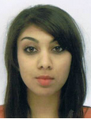
“I would like to thank you for your help and guidance throughout the course. It certainly has
been an enjoyable year” Anjalee Chattersingh OK

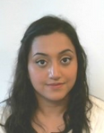
“Thank you once again for everything this year, doing this master's has been one of the best experiences of my life.” Puja Kapoor OK

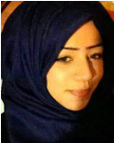
“None of this would have been possible without your support throughout the year. You have been a fantastic course coordinator”
Nur Mousa OK

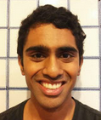
“I would like to reiterate my thanks for your guidance and support over the past year.” Ramith Gunawardena OK

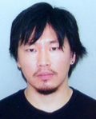
“I had such a great experience throughout the year. I was motivated from the first day I entered the Waterloo campus, and people I met through the course were exceptional. I had so much genuine advice and guidance, and I am confident to say that I want to pursue my career in research in the future. Thank you very much for giving me an opportunity to study under your supervision.” Sho OK

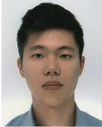

“I really enjoyed the course. It has certainly been a valuable experience. Thank you for all the work you have done to make this course a success.” Chris Seet
