The following is an extract from the introduction to London’s Language, a forthcoming publication and multi-media installation by Tony Thorne and King’s College…
LONDON’S LANGUAGE

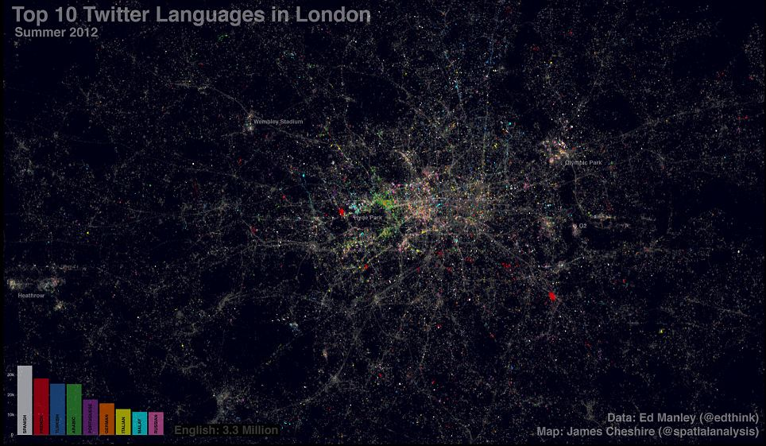

Tony Thorne

Ther was also a nonne, a prioresse,
That of hir smylyng was ful symple and coy…
…And Frenssh she spak ful faire and fetisly,
After the scole of Stratford atte Bowe,
For Frenssh of Parys was to hire unknowe.

Geoffrey Chaucer, Canterbury Tales, c 1370

London, that great cesspool into which all the loungers and idlers of the Empire are irresistibly drained.
Dr Watson, in Arthur Conan Doyle’s Study in Scarlet, 1887

From so many voices, so many writings, this is a distillation of the essence of a very special place – the world’s marketplace and the nation’s carnival - and of the waves of humanity permeating its magical spaces. Though based on scholarly insights and groundbreaking research, London’s Language is aimed at the widest possible readership, appealing to anyone - from the Anglosphere or beyond - who is fascinated by the story of English and the history of Dr Johnson’s ‘wonderful immensity’, England’s capital.
Blowing the dust from half-forgotten files and exploring lost archives, turning up records of confessions from the scaffold, tales of the machinations of workers and shirkers, evidence of individual citizens, rich and poor, confiding their private thoughts to letters and diaries, we will penetrate the closed worlds of street gangs, Travellers, schoolkids, market traders and City slickers. At the same time we will consider more elevated styles and examine the most arresting, most unexpected evocations of the city by its most gifted commentators, from the ancients through to modernists, surrealists, situationists and rappers.

Cockney's not a Language it is only a slanga
And was originated yah so inna Englanna
The first place it was used was over East London
It was respect for the different style pronunciation
But it wasn't really used by any and any man
Me say strictly con-man also the villain
But through me full up of lyrics and education
Right here now you a go get a little translation
Cockney have name like Trev, Arthur and Del-boy
We have name like Winston, Lloyd and Leroy
We bawl out YOW! While cockneys say OI!
What cockney call a Jack's we call a Blue Boy
Cockney have mates while we have spar
Cockney live in a drum while we live in a yard
Say we nyam while cockney get capture
Cockney say guv'nor. We say Big Bout ya
Smiley Culture, Cockney Translation, 1984

In a series of vignettes we will hear, in their own words, the stories of the nuns of East London - the real-life counterparts of Chaucer’s Prioress - the lawmakers and lawbreakers contesting in the courts, refugee poets, the teeming inhabitants of Victorian rookeries and alleys. This title will celebrate the city – and the City - of London by way of the language used within it, and the language used about it, by its many inhabitants and by its visitors down the ages. Like the metropolis itself, London’s language has always been at once sacred and profane, private and public, sometimes stately and sometimes riotously chaotic, once exchanged in the tavern and coffee house, the Royal Court, the ghetto and now in their equivalents today: the café, the club, the inner city estate – and on electronic social media, too.

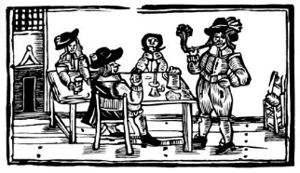

The account of the city’s language heritage begins with today’s range of multicultural voices – the widest range in any global city – and what they are saying about the place they live in, before returning to London’s multiple other incarnations, in folk tradition, in poetry and literature and in private journals and correspondence. The journey ends with the very first voices, the Celtic, Greek and Latin of London’s earliest observers. In passing the book will pay tribute to some of the chroniclers of the city’s cavalcade: the anonymous mediaeval author of the comic ballad London Lickpenny, the tragic 18th century geographer Richard Horwood, whose compulsion to name and number every household in the city drove him to insanity and an early death, Peter Ackroyd, whose enduring obsessions, collected in his millennial biography of London, culminated in a near-fatal heart attack, and seemingly well-known (but actually mysterious) features such as Cockney dialect and slang, but will also uncover lost texts and long-muted voices, hearing from a lesser-known host of renaissance rogues, vagabond poets, spivs, gangsters and other denizens of the street, and uncover recent contributions by artists, musicians, authors of pulp fiction, together with ordinary citizens in their conversations and reminiscences.
When on his Box the nodding Coachman snores,
And dreams of fancy’d Fares; when Tavern Doors
The Chairmen idly croud; then ne’er refuse
To trust thy busie Steps in thinner shoes...
…But when the swinging Signs your Ears offend
With creaking Noise, then rainy Floods impend;
Soon shall the Kennels swell with rapid Streams,
And rush in muddy Torrents to the Thames.
The Bookseller, whose Shop’s an open Square,
Foresees the Tempest, and with early Care
Of Learning strips the Rails; the rowing Crew
To tempt a Fare, cloath all their Tilts in Blue:
John Gay, Trivia, 1716
Linguists know that language, public or private, is never singular but always pluralistic, in their words a shifting and evolving pattern of dialects, ‘sociolects’ and ‘idiolects’. An enduring myth is that Brits, Londoners among them, are ‘monoglots’ and always have been, imprisoned in the one-dimensional reality of a single language. This may have been true of some of us in recent years, but the Londoner of the past was as likely as not to be bi-, if not multi-lingual. The common inhabitants of Roman Londinium, if they wished to better themselves, would have been fluent in Latin as well as in their own Ancient British dialects. Dark-Age traders plying the Thames from Lundenwic had to negotiate the many varieties of Anglo-saxon spoken in England as well as Viking Norse and the ancestors of Dutch and French. For centuries after the Norman Conquest those working in the courts of law had to be tri-lingual as the proceedings were conducted simultaneously in Latin, French and Old English.
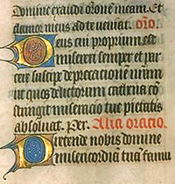

At any time in its history the city has resounded to all sorts of Englishes: the picturesque slangs of costermongers, butchers and pickpockets, the arcane jargon of bankers and lawyers, the polished verbal posturing of salon wits and the literati.

In London there I was bent,
I saw my-selfe, where trouthe shuld be ateynte;
Fast to Westminstar-ward I went
To a man of lawe, to make my complaynt.
I sayd, "For Marys love, that holy seynt,
Have pity on the powre, that would procede.
I would gyve sylvar, but my purs is faynt."
For lacke of money, I may not spede.
An anonymous man of Kent, London Lickpenny, c 1440

Of course the languages of London are not only varieties of English. From the earliest times other tongues have resonated around its hills and streams: the lost Celtic languages of Iron Age Britain, Caesar’s Latin and his legionaries’ vernaculars from around the Empire, the French of mediaeval court and convent, immigrant dialects from Huguenot French and sailor’s Dutch to Yiddish, yielding to the multinational, polyphonic buzz of the modern metropolis.

“If I hole up for a bit I won't stand a chance of earning myself no more. You'll have to sausage me a goose's.” “Sausage you a goose's? What the hell are you talking about?” Len had turned round from the window and was staring at Snowey. “Cash me a cheque, dopey.”
James Curtis, You’re in the Racket Too, 1937

It was in London’s Westminster that English finally became a language in its own right, symbolically used for the first time by Edward III in 1362 at the opening of parliament. It was in London above all that the unparalleled marvel of Modern English, with its plunderings of other European tongues and borrowings from across the Empire, first evolved in the time of Jonson, Marlowe and Shakespeare. And now, five hundred years on, a wholly new hybrid, drawing on sources as disparate as Jamaican, Urdu, Arabic and Gaelic is set, some experts claim, to displace the native Cockney and Estuary dialects of London, even eventually transform Standard English itself into something strange and novel.

Statistics from the latest Census show that 78 per cent of the capital’s 7.8 million residents speak English as their main language. But the remaining 22 per cent — equivalent to just over 1.7 million people — have one of more than 300 first languages. Of these nearly 320,000 declare, rather worryingly, that they cannot speak English well or at all. The most striking revelation, however, is the scale of linguistic diversity. Overall there are 53 community or heritage languages in the capital spoken by at least 0.1 per cent of residents. There are also another 54 which include variants of established languages such as Chinese or those, such as Caribbean Creole, Cornish or Gaelic, spoken by a small number of people. The most common other language is Polish, spoken by nearly two per cent of residents, followed by Bengali, Gujarati, French, Urdu and Arabic. The most diverse borough is Hillingdon, where 107 languages defined by the Census are spoken, followed by Newham with 104. Tony Thorne’s own researches reveal that these ‘other’ languages themselves are undergoing weird transformations as they come into contact with one another and with native ‘white’ London usages.
….
Tony Thorne, a child of the London suburbs, now writes from within the heart of the city, from his vantage point in King’s College and Somerset House, overlooking the Thames just by Waterloo Bridge. For many years he has been reporting, broadcasting and teaching on our changing language and its complex interplay with popular culture, with multi-media, politics and social behaviour. Emulating his 18th century predecessor, the antiquarian and collector of slang, Francis Grose, Thorne has escaped the libraries and gone into the streets to engage with real Londoners and record their words. Since his childhood he has been fascinated by the spectacle of London, from the desolation of the mudflats, marshes and deserted ferries of Silvertown to the East to the riverside promenades, meadows and parks of Richmond and Kew in the West.

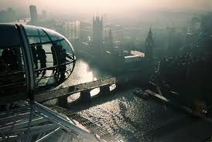

Copyright Tony Thorne/KCL Slang and New Language Archive 2014

